

Yarmouth Little

Stars

Parent Assessment

Checklist

Please don’t look upon this form as a ‘test’ which your child has to pass. There is now right or wrong answers.

This form is to give us some idea of what activities will benefit your child.

Try to answer the questions as honestly as you can, if you don’t know all the answers don’t worry.

Please also use this form to let us know anything else, which you think is important, which might affect their learning.

Any other information?

Any special Needs

Name of child …………………………………………………. Date of birth ………………………………………………..

Pre-school experience □ Playgroup □ Nursery □ Home

Speech therapy □ Yes □ No

Please tick the statements which apply to your child.



**Self Help**

□ is able to do things for his/herself (go to the toilet, put on coat, etc., without help)



**Social and Emotional**

□ likes playing with other children

□ prefers to play alone

□ is shy

□ has an outgoing personality

□ will talk easily to adults

□ plays co-operatively





**Colour and Shape**

□ knows the colours

□ can count to 5 or 10

□ recognises these numbers

1 2 3 4 5 6 7 8 9 10

□ recognises a square, circle, triangle and rectangle

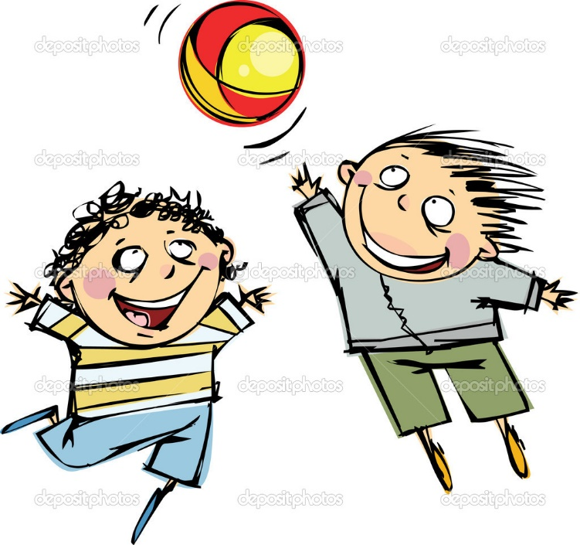

**Physical Skills**

□ likes to run and jump

□ can climb safely on a climbing frame

□ can pedal a bicycle or tricycle

□ can throw, catch, and kick a large ball



**Manual Skills**

□ likes to do jigsaws

□ can build a tower with blocks etc.

□ uses pencils or crayons to make marks on paper

□ can use scissors



**Use of Books**

□ likes to look at books

□ enjoys sitting quietly and listening to a story

□ will share a book with an adult telling them the story

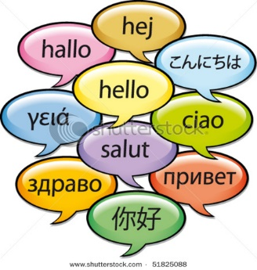

**Language**

(spoken and written)

□ knows simple songs and rhymes

□ is able to follow simple instructions

□ speaks clearly in sentences

□ is sometimes hard to understand

□ uses single words only