Dear Parents and Carers, 3 May 2019

Further to the recent informal consultation under taken by the IW Council aiming to address the issue of surplus pupil places in primary schools in the West Wight, we write to you to update you following today’s announcement.

During the six-week informal consultation, a number of alternative proposals were put forward to the IW Council, one of which was to close All Saints CE Primary School and relocate Yarmouth CE Primary School to the All Saints site. As a result of the consultation, the governors were approached by the Local Authority to ask our view on this particular option. The governors met to discuss the proposal and as a collective felt that it would be appropriate to ask all our stakeholders what their view would be on this option given that it involves not only our schools but also a significant change to the community beyond the school gates and for the long term. The governors therefore agreed to a further informal consultation period giving our staff, parents, children and the wider community the opportunity to come together and discuss this option carefully before any decisions are made.

We await the Cabinet member for Children’s Services’ decision on 13 May 2019 whether to go ahead with a further informal consultation before we undertake any next steps. If the decision is to go ahead, we will hold one or more consultation meetings should you wish to speak with LA representatives and school governors in person. We will then also be sending you a questionnaire, which we would ask you to complete to share your views.

We are very clear that if the informal consultation goes ahead, it is exactly that, an informal consultation and no decisions have been made. Our focus is to represent the Federation, keeping the best interest of the schools and the children at the heart of what we do.

As we said in our previous letter, we fully support our Headteacher and her staff and wish to ensure they have the space to do their jobs to the best of their ability and we will endeavour to protect them from any distractions, which divert them from the task of continuing to deliver high quality teaching and learning. We therefore ask you that if you have any questions to please contact the governors either via the clerk on clerk@yarmouthceprimary.co.uk or via the school offices: Shalfleet - 01983 760269 and Yarmouth - 01983 760345. Thank you for your support.

Yours sincerely,
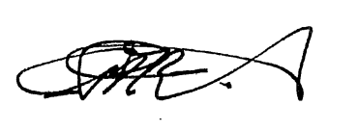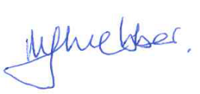
Carla Bradshaw Mark Webber
Co-chair of governors Co-Chair of governors

