



 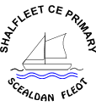

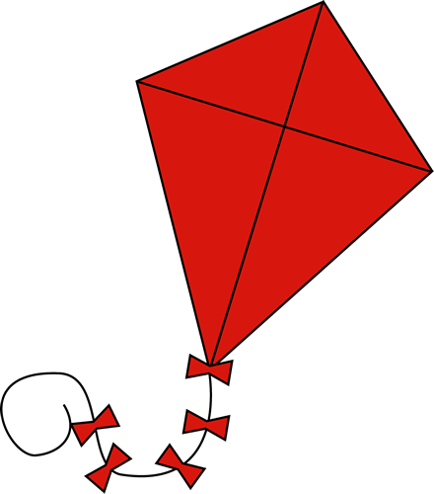

KITE INFORMATION

Community & Curriculum

**Excellence for Everyone**

* To increase the percentage of girls achieving the required level in the phonics test
* To increase the percentage of pupils reaching ARE (Age Related Expectation) in Y2
* To increase the percentage of pupils making at least expected progress from Key Stage 1 to Key Stage 2 To increase the percentage of pupils in Year 6 at Yarmouth who achieve ARE
* To increase the combined percentage for Key Stage 2
* To develop middle and senior leadership to have a robust understanding of whole school data.

Excellence for Everyone



**Culture of Challenge**

* To increase the percentage of pupils at Yarmouth attaining Greater Depth in Maths
* To increase the percentage of pupils at Yarmouth attaining Greater Depth in Reading at Key Stage 2
* To increase the percentage of pupils at Shalfleet attaining Greater Depth in Reading at Key Stage 2
* To increase the percentage of pupils at Shalfleet attaining Greater Depth in Reading, EGPS and Maths at Key Stage 2
* To increase the percentage of pupils at Yarmouth attaining Greater Depth in EGPS, Writing and Maths at Key Stage 2

**Closing the Gap**

* To ensure the new pupils who have entered the school make at least expected/accelerated progress
* To increase the percentage of new pupils reaching ARE in their reading, writing and maths
* To increase the percentage of disadvantaged pupils achieving expected progress and achievement in reading, writing and maths
* To increase the percentage of pupils with SEND achieving expected progress and achievement in reading, writing and maths

Culture of Challenge

**Kites**

At the Federation of the Church Schools of Shalfleet and Yarmouth, we are serious about school improvement and set our sights high for the learners in our schools. We write our school improvement plan on ‘kites’ to raise aspirations for all our learners – both adults and children!

We believe in a strong, working relationship with our parent community is essential in improving our schools and outcomes for all learners.

EXCELLENCE FOR EVERYONE

Closing the Gap

Community & Curriculum

Culture of Challenge

Closing the Gap

