YARMOUTH C.E. PRIMARY SCHOOL RESPONSES TO THE CONSULTATION
PARENT VIEW – WEST WIGHT CONSULTATION – LA NEW PREFERRED OPTION

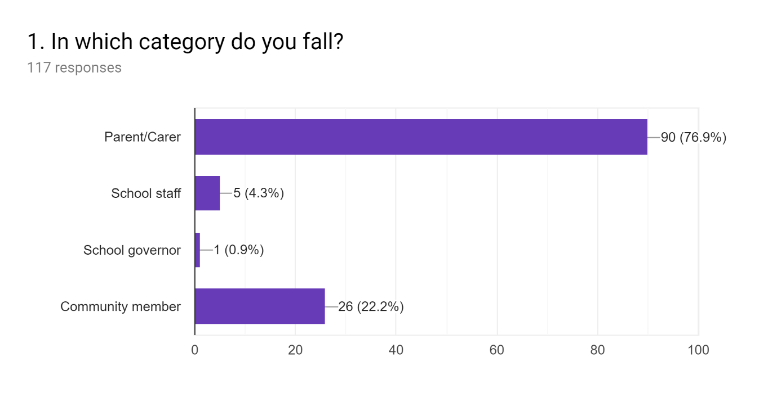
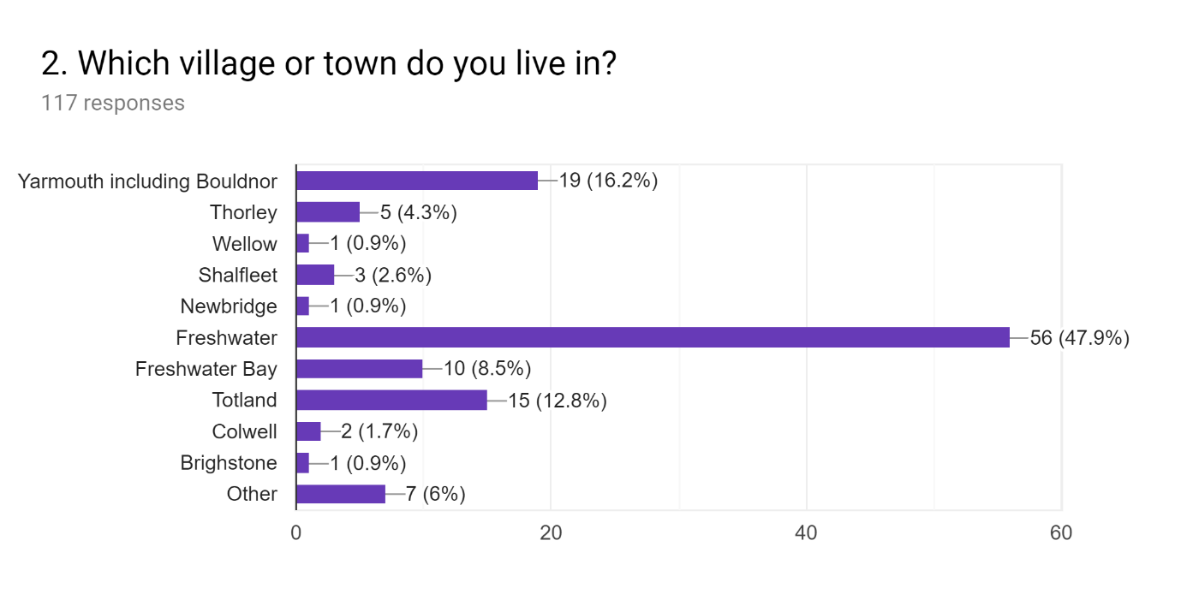
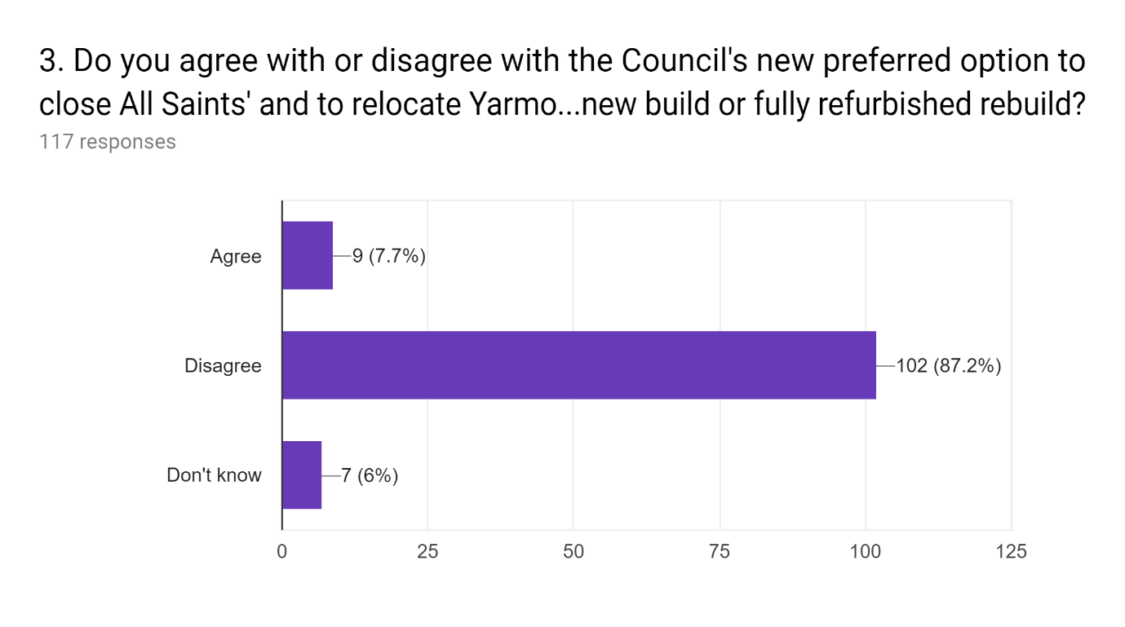

Additional comments
I strong disagree with this proposal. Yarmouth school in its current location is a shining example of a thriving school in the heart of the community. If anything the school should be used as an example to other communities. I feel that moving Yarmouth school will deeply effect the local community and disrupt the educational needs of the children. Yarmouth sets the bar for high quality education and community values, something other schools just fail to offer.

I disagree completely with the latest preferred option that the council is trying to push on our respective communities. I believe any move will be to the detriment of the children of our school and those children at All Saints. Having worked in the community, the reason so many of the children thrive at Yarmouth that have struggled elsewhere is undoubtedly the staff, school environment and it’s surroundings. The fact it is a small school makes it much more accessible for children with any difficulties accessing school due to emotional issues. I am concerned my son will suffer from any move and will do anything possible to make sure his education is not disrupted. I also have serious concerns that moving children to the Yarmouth site as an interim is not achievable in real terms as the site is not big enough to accommodate this successfully in the timeframes given. There are not enough toilets on site for that number of children, the school playing field would be significantly impacted by temporary class rooms and school assemblies would have to be split to allow all children and those parents that wish to attend to be part of them. I feel we have go to this point as the local authority did not make it clear that all schools were at equal risk in the original consultation. As Yarmouth was not named in the original preferred options, understandably, many Yarmouth parents I spoke to did not realise they had to respond. All Saints parents are rightly fiercely protective of their own children and do not want to see their school close, so Yarmouth has subsequently been put at risk due to the responses from that first consultation. Many parents I have spoken to believed Yarmouth school to be safe from closure due to the wording of the original consultation and did not respond. Having worked in the local area, I am aware just how much Yarmouth school is part of the wider West Wight community and it is the heart of Yarmouth. By 'moving' it to Freshwater, not only will the children suffer, but I believe that Yarmouth town will never be the same again. The amount of outreach and in reach that happens with Yarmouth school is a testament to how well respected it is in the community and how the community and the school mutually support each other. I also have concerns that those children most vulnerable to the move will be from vulnerable families who do not have the technical know-how or confidence to respond to the consultation in a way that will adequately describe what impact this will have on them. Also, figures that have been released that show by reducing PAN, All Saints can reduce the spare places to equal or more than merging the schools would do is reason enough not to do it. I do not see any evidence that opening a new, larger school in Freshwater is in anyway going to achieve what the local authority are claiming. It will not reduce the surplus figures sufficiently and will also make parents have to reconsider their schooling options, especially for those who struggle in larger environments. We seriously have to think about the future for not just our schools in isolation, but what these changes could do to our area of the Island. All these things are interlinked; by reducing the number of schools, communities are affected, the attractiveness of an area for people to move into it is affected and we already have a tough job attracting those in professional occupations to the island. We have an ageing population here in West Wight, removing schools is not likely to redress that balance and where are the younger generation going to come from to care for our ageing demographic? Please do not accept this latest proposal. I feel that moving a successful school to the site of a consistently underperforming school is not the answer to the latest budgetary woe of the council. Those councillors will not be the ones affected by the fallout of this, all of our children will be. You have a good school for a multitude of reasons; our communities need to push back to those in power. They may hold the purse strings but that does not mean that their ill-informed proposals are correct. There must be a way to keep our small schools in place whilst reducing the student numbers in line with government 5% surplus recommendations.

It’s crazy idea and would be a lot of disruption

I am concerned for a disruptive year for my son, who will be in Year x next year. I also love Yarmouth for it's small, community involvement and family environment and I am concerned it would lose this. I think it could work, however I am unsure and worried about the merger, particularly with playground gossiping between parents and obviously that will filter down to children, with potential for increased bullying and vulnerable children being made to feel more vulnerable. It would have to be very carefully managed.

The move of Yarmouth school to the Freshwater site will decimate the town of Yarmouth. In addition the interim arrangements will cause huge disruption and destabilise a strong federation and school with high attainment. There are other solutions that maintain the high performance of Yarmouth school within its unique and educationally supportive setting that don’t disrupt the education of our children with two transitions. Please reconsider the preferred options.

This is only if the staff feel confident that they can handle the change in both location and student number. Managing the change for the kids is the most important and issue in this. It can either make the children more resilient or impact their schooling negatively. I also want confirmation from Caterlink that the staff in Yarmouth will transfer over.

Myself and my family love yarmouth primary school. However, I sent my child to this school because of the head and teachers, not because of its location or building. I can clearly see that it's not viable to have a school in yarmouth for the amount of children that live there, compared to the hundreds of children that live in freshwater, it only seems the more sensible option to keep a school in freshwater rather than yarmouth. I personally feel by relocating this is our only way to actually save our school,as if we don't and the admission numbers do keep falling, yarmouth will be next on the hit list and will end up actually closing, which in turn will mean our teachers will lose their jobs and our children will be scattered around the west wight area leaving behind everything they've ever known. Not only that, but this could be a fantastic opportunity for our children's education in the west wight, by getting a purpose built school with science labs and cookery rooms all being well. Ultimately this is not just about yarmouths pupils, this is about all saints pupils too, if this means that they get to stick together and have some kind of a smoother ride then I'm all for it, because I have every faith in our head, teachers and governors to pull this off and make it work, and make a new building as fantastic as the old one.

A new building is not what creates a good happy school and learning environment. We chose Yarmouth due to its links to the Yarmouth community not Freshwater. The disruption to the children's education and impact on their mental health would be catastrophic. Yarmouth School is of paramount importance to the town. Freshwater has numerous churches and a sports centre, Yarmouth does not. The school needs Yarmouth as much as Yarmouth needs the school. The only way to reduce the deficit of pupils in the West Wight area enough would be to stick to the original plan, Close All Saints and expand St. Saviours. In addition by reducing the pan for Brighstone Primary the council would reach its objective. Why should a good school close / be moved because another is failing? It makes no sense, especially when it doesn't solve the original problem of reducing excess pupil numbers.

This is a ridiculous idea. Yarmouth is a really good school. My son is thriving. The teachers are amazing at what they do, and the community spirt is what makes it a great school.

- Accepting a large number of pupils and the subsequent building and teaching changes will mean significant upheaval for children. 2. We have exercised parental choice in choosing Yarmouth, our location is not relevant. 3. We will consider moving our children to another school if this proposal goes ahead. 4. Yarmouth as a community will lose the benefits of children attending numerous events - the school is part of the fabric of the local community and why we chose it. 5. The timescale for these proposals is very short and will cause very important decisions to be rushed. 6. The proposal as it stands does not solve the issue with pupil surplus.

As long as it's a new building they put up on the All Saints site and not a refurb. Also the Little Stars preschool needs to stay with us.

This was proposed by the Freshwater community without them consulting us first. They want to save their school obviously but it is wrong to destabilise a thriving federation school because of their (three times badly rated) school closure threat. Why is no one saying anything about Brighstone, is it because Vix Lowthion, part of the campaign to save Freshwater School (and now officially saying that Green Party won't back our petition) has kids there? As to the fact that so many travel from Freshwater, is that not also the case in Shalfleet? people travel to good schools. All schools in West Wight serve an area. It is also very short-sighted to assume the island demographic is stationary and pupil numbers being only about birth rates. With new homes being built, especially around Shalfleet and Yarmouth, doing anything to the West Wight Schools seems ridiculous, since people move to the island all the time. Weston site is a ghost of a place now, that is not what Totland and Freshwater needs, it needs regeneration.

Why are you wanting to close a good school and relocate to it save/help a poor performing school?

My grandson attends the school

I chose Yarmouth primary although All saints is just a short walk from our house. I’m willing to drive my son here because I preferred the smaller school environment & great reputation the school has. I felt it was the best option for my son’s education, I love the community feel it has. I feel upset that because of another school performing badly, our lovely school is at threat of ‘relocating’, when it is doing so well.

The situation should never have been allowed to reach this stage. All Saints' Governors and the authority should have reacted to the numerous staff losses/ changes and the fall in roll at least 5 years ago and taken appropriate action. All Saints was a popular and thriving school for many years previously.

I feel this would have a negative impact on the pupils of Yarmouth school. A successful school shouldn't be compromised in this way.

It will not be Yarmouth school in located to Freshwater let’s be honest. You can say it’s yarmouth teachers and staff but it will still be Freshwater school

All saints school should close like originally proposed as it is ultimately a failing school. There clearly isn't enough parents in the West Wight area who would choose to send there children to that school- this has been proven in the massive decline of children wanting to attend this school. The children's education should be the main consideration when choosing which school should be closed. Yarmouth federation with Shalfleet school works well and has been ofsted rated good. The pupils who have attended this school are all doing well and achieving good grades. All saints has been underachieving and not achieving such high grades. If you are to move the children temporarily to Yarmouth and then relocating all children back to all saints new school that will be causing disruption to two schools pupils education rather then just one. If all saints is to close the parents of all saints pupils should be offered choice and be able to choose between the 4 remaining schools in the west Wight area that they would like their children to attend. My grand daughter is a very timid girl who will desperately suffer with these proposed changes. This was one of many reasons we chose to send her to Yarmouth school. The chaos that this proposed idea will cause is unthinkable so many children's education will suffer. Yarmouth currently is not big enough to facilitate all the extra pupils from all saints school. Portacabins will need to be used and porta loos this will decrease the outside space for the children massively. The school already have their lunch in two sittings as the hall can't allow them to all have lunch at once... So by doubling the amount of pupils will mean lunchtimes need to be done in 4 sittings? I totally understand that a school needs to close due to the surplus spaces but this proposed idea should not be considered as it will cause the most amount of disruption to the most people.

I am very worried about my children's emotional wellbeing with the disruption of a whole new school moving to Yarmouth he has thrived in Yarmouth and with this new proposal with effect him massively then to all move to a new site At an unknown date he would not cope with and would need a lot of support that may not be provide for him!

I would prefer Yarmouth to raise it's PAN and remain where it is in order to keep it's unique position and identity as a small rural school with it's good Ofsted rating. The smaller school is chosen by parents for what it can offer their children and the good standards it maintains, I fear this could be lost if relocated

Yarmouth is struvrd to be a successful primary school and its achievements should be rewarded, there has been a school on site for generations and the current children deserve the same stability offered to previous years. Parents have chosen Yarmouth and their opiond should be 100 percent respected

Having initially been supportive of the idea i have now had the misfortune to attend the meeting at Yarmouth School and I feel that the combination of emotions involved on both sides, the intended lack of engagement with the process from some sides and the councils lack of a clear plan I will only cause greater disruption to the education of a greater number of children.

The destabilising and disruptive effect this proposal would have upon an existing strong school will have a lasting and detrimental impact to all those currently going through their primary education at both Yarmouth and All Saints.
As s yarmouth resident this make travelling to school very difficult

The stated objective of the current consultation regarding schools in the West Wight School Place Planning Area is to “tackle surplus school places”. There is a clear need to tackle this as schools operating beneath their PAN struggle financially which often seems to adversely affect a school’s Ofsted rating & SAT scores. Poor results in these metrics can damage a school’s reputation and lead to dwindling pupil enrolments. It is clear from the council’s proposal to close All Saints’ CE Primary School and relocate Yarmouth CE Primary School to the Freshwater site, that it is the council’s belief that All Saints’ has entered such a downward spiral and that moving a school with a good reputation to the site will overcome the problem of dwindling enrolments and reduce the number of surplus school places. It is my belief that the council's proposed solution will fail utterly on the first count and, on the second count, does not go far enough to tackle the issue in order to avoid further action having to be taken in the near future. I do however have an alternative proposal which I believe could reverse the fortunes of Freshwater’s primary school and protect all of our local communities from any adverse effects of the closure of one of our schools. Let me first describe how I believe that the relocation of Yarmouth School to the Freshwater site will have a negative impact on the school & community of Yarmouth and fail to overcome the poor reputation & flagging enrolment numbers at the site currently occupied by All Saints’: -Yarmouth Church of England primary school is demonstrably a success, it has a high number of enrolments, good SAT results and is consistently rated “Good” by Ofsted. However, its success is not merely academic: -The school is central to the community and plays a very active part in many community events, from Pancake & duck races, in the spring, right through the year to the carnival & carol services. -Yarmouth school also enjoys a location which allows easy excursions to the local fire station, lifeboat, Mill copse, the harbour, pier, castle, beach and slipways. -The school’s involvement with these community events and through making use of the surrounding environment in the children’s education, serves to influence the children’s social awareness, further endearing the school to local families. -The school building adds to the attraction of the school: the ease with which children move between Little Stars Nursery and the reception class, with their shared learning spaces, makes the transition from nursery to school almost seamless for the children & their families. -The ascetic of the 1850’s schoolhouse strengthens the image of a small-town school with its small classes & community ethos. None of these things can be taken with the school, should it be moved to the Freshwater site but they all add to the positive outcomes of the pupils and the desirability of the school amongst families when considering where to enrol their children. All Saints’ poor reputation amongst the community is well known. Many families cite a poor relationship with the head teacher as their reason for moving their children from the school. Others have chosen to enrol their children in alternative schools, despite All Saints’ being their closet option, because of the reputation of the head. Some have been put off by the school’s poor Ofsted rating and SAT results. On the surface the council’s proposal may seem to offer solutions to these issues but they fail to tackle the other thing contributing to the school’s poor reputation. That is stories like the one featured in the County Press, where a parent jumped the fence one sports day to start a fight. This aspect of the school’s poor image is much more challenging to overcome but it is the reason why a brief glance at any social media forum, where this is being discussed, exhibits a large number of families who are unwilling to enrol their children in any school on the site currently occupied by All Saints’. Without tackling this aspect of the school’s negative reputation any school on this site is doomed to undersubscription, underfunding and the downward spiral that almost inevitably leads to. Freshwater does have need of its own primary though. The most recent population growth forecasts for the Isle of Wight do show the number of children decreasing as a share of the population by around 2% by 2027 but as the population as a whole is set to increase by around 3.7%, this still represents a net increase in the number of children requiring school places. The council’s “Island Planning Strategy” includes plans for 425 new homes in Freshwater and with these new homes will come new families, increasing demand for school places in the village. The “Island Planning Strategy” also details plans for well over 1000 new homes across the rest of the West Wight, the vast majority of these homes are to be built in the villages between Shalfleet & Yarmouth. Any children of families occupying these new developments will obviously take priority over the children of Freshwater when it comes to allocating school places at the nearest schools of Shalfleet CE Primary & Yarmouth CE Primary. Currently many families from Freshwater chose to send their children to Shalfleet and Yarmouth Schools but the increase in population may deny them this option in the future. So, although there is a diminished need for school places in Freshwater at present and in the immediate future, by 2027 the likelihood is that demand will rise again. Any plan for the future of primary education on the West Wight must therefore seek to reduce the surplus places in schools which are currently undersubscribed while allowing for future population growth and the inherent increase in demand for school places. It must also seek to overcome the bad image from which Freshwater’s school suffers. The way in which I propose tackling the first issue is to reduce the per year PAN of Brighston to 20 and All Saints’ to 15, to restructure their year groups to match those of St Saviours and Yarmouth respectively and to close off or repurpose those parts of the schools which are currently surplus to requirements. Doing this will reduce the total number of surplus school places from 29% of the total number of places available across all of the schools on the West Wight to just 9%. The council’s favoured proposal of closing All Saints and relocating Yarmouth school to the Freshwater site would only result in a reduction of surplus places to 19% of the total available. Reducing the surplus school places in this way should address the current funding shortfall while also allowing for easily increasing school places in the future should the need arise. Tackling the second issue is more challenging but I believe can be achieved by offering something at Freshwater which is not available at any of the other schools in the West Wight School Place Planning Area. As it stands, all of our schools on the West Wight are affiliated with either the Church of England or the Catholic Church. If Freshwater were to offer an education experience free of any evolvement with organised religion, the school could well attract some of the many families who don’t share the religious beliefs being promoted in all of the schools currently available to them locally. This is a growing demographic and one of the factors which has contributed to an increase in the number of families choosing to home-school their children. Overcoming the bad feeling many families currently harbour towards Freshwater’s school seems an insurmountable obstacle but by offering a learning experience, unique to Freshwater amongst the schools in our local area, new families may be attracted to the school when their children reach school age. To summarise, my proposal is to: -Close All Saints’ CE primary school at the end of Summer Term 2020 -In time for the beginning of Autumn Term 2020; open a new, non-denominational school for Freshwater on the site currently occupied by All Saints’ under the leadership of a new board of governors & Head Teacher with a per year PAN of 15 -Reduce Brighston CE Primary School’s per year PAN to 20 and restructure the year groups & school infrastructure accordingly.

Depends on a lot for us as my child has additional needs

The school is successful because of the strong Governorship and management AND the closer links within the Yarmouth community. We also cannot replicate the natural resources within walking distance. I believe this move is not realistic and will detrimentally affect the stability of the school. It will disrupt and immediately drive down the standards which we have worked so hard to improve. My child will be taking SATs just a few months after this massive, and unplanned, upheaval and change in pupil numbers. He will be so massively negatively impacted that I feel I cannot subject him to this and will be forced to look for other options for schooling him- even if I have to drive him to school in Cowes or Newport everyday or homeschool. This option does not even reduce the surplus places which the Council want because we have just found out that AllSaints have successfully applied to reduce their PAN to 15, so their school capacity will be 105. The first preferred Option of closing All Saints and expanding St Saviours DOES reduce the West Wight Surplus, and reduces the number of transitions for pupils, and number of pupils affected, so why is that not being taken? All the West Wight shools (apart from All Saints) have pupils from a wide area. Yarmouth is not unique in this.

There is NO need to disrupt and punish so many children. Move all saints children to saint saviours who will be able to accommodate them

Closing or relocating Yarmouth is ridiculous I strongly disagree with this proposal.

Strongly disagree. We need to keep yarmouth school in yarmouth!!!

Yarmouth school isn't yarmouth school if it isn't in yarmouth.

Parents have shown that yarmouth is a superior school in terms of teaching, location and overall ambience and community. They could have sent their children to freshwater if it’s closer to them but they decided not to. Funding and support should have been given to freshwater school to improve the standards there and encourage parents to register their children there for local families. Closing schools in west Wight will have the reverse effect because families won’t move to the area if not enough choice in schools are provided. Businesses rely on residence moving to west Wight not being discouraged from settling here. West Wight is a large area and parents will most likely have to drive their children some distance to school anyway. Families are moving more and more from the mainland due to increased property prices on the mainland and the modern ability to work a lot via the internet. Yarmouth is a prime location for this due to its links to the mainland and small community. The island economy as a whole needs people of this age bracket to move here.

It wouldn't be Yarmouth school any more. The school is heavily involved within the Yarmouth community and the school is just beautiful. Relocating would lose all of the amenities and community spirit.

Terrible short sighted proposal that should never have seen the light of day.

We need to address the issue of excess spaces in the West Wight and make a decision best placed to tackle this.

As long as same head and deputy/staff

I disagree strongly, yarmouth is too small for these children to attend. My daughter struggles with change and needs the small school environment to help with her learning, she is doing so well at school at present. My son had all this when weston closed, we choose yarmouth as it is a brilliant school. My daughter started school a month after her 4 th birthday and is still so young, this would really upset her learning. I still have days where she gets anxious to attend school but the teachers are amazing an help me with this. With a bigger school I just don’t think she would get the support she needs.

There are benefits eg wider peer group, better facilities, transport, sustainability for sure, and benefits perhaps in an ncreased budget for the school, new staff with additional skills and more parents to input in terms of fundraising, reading, after school clubs. And wider benefits too for the economic regeneration of the West Wight which is sorely needed as I am sure you witness working with the children. But I'm extremely anxious about IWCs education record, this "consultation" and the LA leading this flawed process which allows the loudest to be over represented and the ill-informed to sway opinion. Putting their involvement aside, whilst iI'm not at all certain that our "Good" school will survive such a fundamental change in its makeup, I do fully believe all of you, staff and governors will try your best to effect these changes smoothly and efficiently in response to the need to change the current primary provision in the West Wight . I don't believe a larger school would be " too much" for you. I'm also very confident that we can together grow a strong and healthy community spirit around the new school, helping to make a dynamic new school with beneficial links to many businesses and organisations in Freshwater and putting it at the heart of a more diverse community. As a school we are so much more than occasional events in the square and the building. Whilst I appreciate the history and heritage to Yarmouth school, it has outgrown its site and its future is I believe in effect limited by the surrounding inactive, ageing population, predominantly vacant second homes and high price tourism outlets. I personally don't rate this idea of an amazing, irreplaceable or unique yarmouth community highly, not only because Izzy only has about 4 children in her year she started with - the rest have come or gone. I have taken time to come to this view, quashing my initial reactionary emotional response in an effort to be rational and more positive toward potential change. In summary, we could be ok if we have a plan that puts the childrens needs first under your good leadership and the budget under our control. With investment into reaching out to the local community, it could even turn out well.

Yarmouth is a fantastic school. Why mess up children's lives and relocate them to a school with a bad rating?

I don't actually mind the relocation but I have concerns about larger class sizes, about new teaching staff for my child who has got on well with the current ones. I am also concerned about the behaviour of new students and some of the local children have a bad reputation for being very rough and there is plenty reports of bullying currently at all saints but it is not tolerated at Yarmouth which i find very reassuring currently.

There is a reason parent's have been choosing different school's in the West Wight area in the last few years and not using the freshwater school that already existed. It has been ofsted rated RI for years now and nothing has changed. So by moving a good ofsted school to this area will affect that ofsted rating. So you have said all staff are safe but what about the pre-school. There will not be 2 on one site which does affect the Staff who have worked very hard to get a ofsted rating of good

As Freshwater is the largest village on the island it seems logical to keep a primary school in Freshwater. Ideally it would be great to keep all primary schools open in the West Wight. Which would make everyone involved happy. Also with the proposed building of 500 property's in Freshwater it seems ludicrous to close All Saints. I'm lead to believe that 3 quarters of pupils at Yarmouth primary are Freshwater/Totland children. All Saints site is in an ideal position for a school. It's close to Library, Church, sports centre and nature reserve. It's off the road and has safe lanes and roads for local children to travel to school. My parents, my brother, sister, myself and my girls attended All Saints and it would be nice for my granddaughter to attend when she is school age. I really hope All Saints is saved

Yarmouth School is a great little school providing superb education. Yarmouth has always had a school and this needs to continue. The school is very much a part of the Yarmouth community as a whole. I attended Yarmouth myself 50 years ago!

We exercised parental choice in sending our daughter to Yarmouth. We chose Yarmouth because of its community links. Merging two schools of almost equal size on a site of insufficient size and resources will be detrimental for all children. Merging two schools will be damaging for all pupils’ development and will be extremely challenging for staff due to the vastly differing levels of attainment. The proposal calls for a hugely rushed approach which does not allow for proper preparation or research in to providing a good education for children.

I am a grandparent of a child in the school also a local resident

It’s not a viable option moving a good school to another site to save 71 childrens education, when in the process you are in fact disrupting double that by doing so! Asking them to move twice in the space of two years, asking them to be cramped into awful conditions for the sake of this move to a promised ‘super school’ which nobody really wants or needs The most viable option and the one which makes the most sense and more than likely is the most financially viable or else it would not of been suggested by the iwcc is to move the children to St Saviours
Keep all schools open as they will be needed with all the proposed buildings
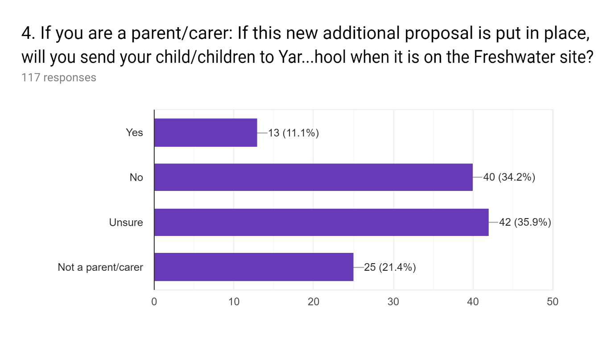
Additional comments

We would seriously consider homeschooling

No , my boy is due to start high school sept 2021 so hoping won’t effecg him but won’t put him at new site then high school , he’s autistic and we already worried how he ll cope with the high school transistion

I fully support Mrs Grainger and her leadership. I would support in any way I could.

I will reconsider my children’s educational placement based on the short term disruption this reorganisation would cause on there long term educational outcomes.

The freshwater site is within walking distance and if the same level of education can be provided there, I welcome not having to drive the school run.

Absolutely. As I said above, a new building is a fantastic opportunity of our school and children.

Additional comments for nos5 not working: Given that the funding to teach any incoming children has already been spent at All Saints where is the funding going to come from to teach any extra children that chose to come to Yarmouth. Given that school budgets are already at breaking point the council will need to allocate more funding beyond any additional material class room space. It could be that the school could interview outgoing all saints staff to be employed on a temporary contract that would be funded by the rest of the money from All Saints budget but the school should have the option for funding from elsewhere should they find the All Saints staff unsuitable and not be forced in to accepting re deployment of existing staff. Whilst the staff at All saints are not to blame for the situation it shouldn't be the responsibility of the other local schools to pick up the pieces from years of poor management.

If all the yarmoth staff are there then I will! I have built up a good relationship with them over the years and don't wish to loose them
This would be impossible for us. Out daughter is due to start Little Stars in September has SEN including feeding problems which mean she can't be fed then put in a car seat for at least an hour after milk/food. We would have to move our son to Shalfleet so that he can be dropped by his father on his way to work. We deliberately moved to Yarmouth to enable us to walk to school.

It will not be yarmouth school anymore.
The disruption of the implementation of the proposal, would cause us to consider moving our children before the site opened on freshwater and we wouldn’t want to them move them again!
Absolutely. A building is a shell, it's what inside that counts. The staff are amazing and wherever we go we take our joy, compassion and spirit.
We live in Freshwater, we were part of the number of parents who moved their kids from Weston. We did not choose All Saints then and we will not choose it again. I would rather home school than put my kids through it again. It was traumatic for all involved, how dare they suggest I put my child through that again.. So they can count two kids off for not moving anywhere. When Weston closed most of the pupils went to Yarmouth, then St Saviours, and finally one or two to All Saints (of which one moved to Nine Acres soon after). I know the proposal is not about closing Yarmouth, but that is exactly what it would be. Yarmouth Primary school has over 150 years of traditions linked with Yarmouth: Pancake races, Carols in the Square to mention just a couple. The estuary, forest and copses provide exceptional places for children to learn about nature, the ferry links provide a fantastic link for school trips. The disabled access at the All Saints site is horrendous with its slopes.
I’m not going to send my son to ‘Yarmouth primary’ on the preposed new site in Freshwater. If the change goes ahead he will be looking for a new school.
Unsure would prefer Shalfleet if there was the room rather than Freshwater
My grandchildren may be sent to an alternative school
It may be too distressing and emotionally hard for my son
Children at Yarmouth have already had the largest influx from weston to force the same 🧒 to merge again is extremely unfair on those individual children
I fear the disruption would be too great. It would start with a large surplus number of spaces that would be hard to over come leaving it once again at risk.
If the proposal was to go ahead, then it would force me to consider the best options for my children’s education.
I would reconsider my children’s school
The reputation of the All Saints’ site is too bad for me to consider sending my child to any school on the site. A number of friends of my child have already enrolled in other schools in preparation for the proposed moved. The school will be undersubscribed, underfunded (thanks to per pupil funding) & destined to fail, my child’s friends won’t be there and therefore there is very little to attract me to the school.
I will be looking for another school for my son if Yarmouth were to relocate to the All Saints site, as the school doubling in pupil numbers I believe would have a detrimental effect on his education.
As my comments above, I will not subject my child to this and I find another school or home ed.
Absolutely not. It’s an insane option!
It will no longer be Yarmouth school
My grandchildren will most likely choose an alternative school perhaps outside of the West Wight.
I may look for a school outside of the west wight so they aren't caught up in all this mess!!
It will depend on availability of places at shalfleet, we will consider moving house.
I’m unsure at present until I am more certain as to what’s happening
May reconsider shalfleet
I would have to
My child will not attend all saints
Be good to have bigger grounds and one class per year group
This would not be the right option for my daughter. If brighstone and all saints are both in the same situation why not combine them, both have improvements needed why shut a good school?
I want a school with that isn't going to be making massive changes constantly for the next few years as I want my child to feel secure
A - the choice to go to Yarmouth is being taken away from our family B- Our family chose Yarmouth for my grandson because of the smaller class size as he has speech and language difficulties as this school was better for him C- This would completely change times for family to get my grandson to All Saints and then get to work on time as no parking in school
They will be classes of 30 at a one school formations there would be so many children there overall that I feel this would affect my child's education. Having a larger school will have more children at play time, lunch time and using the facilities. There is no car park on site and for days like sports days and Christmas plays the local car park will not fit the larger number of cars going to the school.
My child has problems with interacting with large numbers, hence why we put him in Yarmouth
It will not be the same school with the same community support.
Not sure if my daughter will want the children go to All Saints, we may well take them to Newport school as she passes through for work daily
I chose Yarmouth as a school I do not want to send my children to A site in freshwater I would hope the federation may take children at Shalfleet of there are spaces that could be made available or else I would go into Newport
We do not want our son to go through all the disruption of being educated in a chaotic environment on the Yarmouth site and then have him put through the disruption of moving to the Freshwater site as well and having to settle in there.
I live in the Yarmouth area and work in Newport so would not be suitable
We do not want our son (a) educated in a chaotic environment on the Yarmouth site whereby the children lose their playing field also and (b)we certainly don’t want him then then put through all the disruption of having to settle on the Freshwater site. This is too much to expect such young children to cope with. No responsible parent would agree to their child having to be put through this.

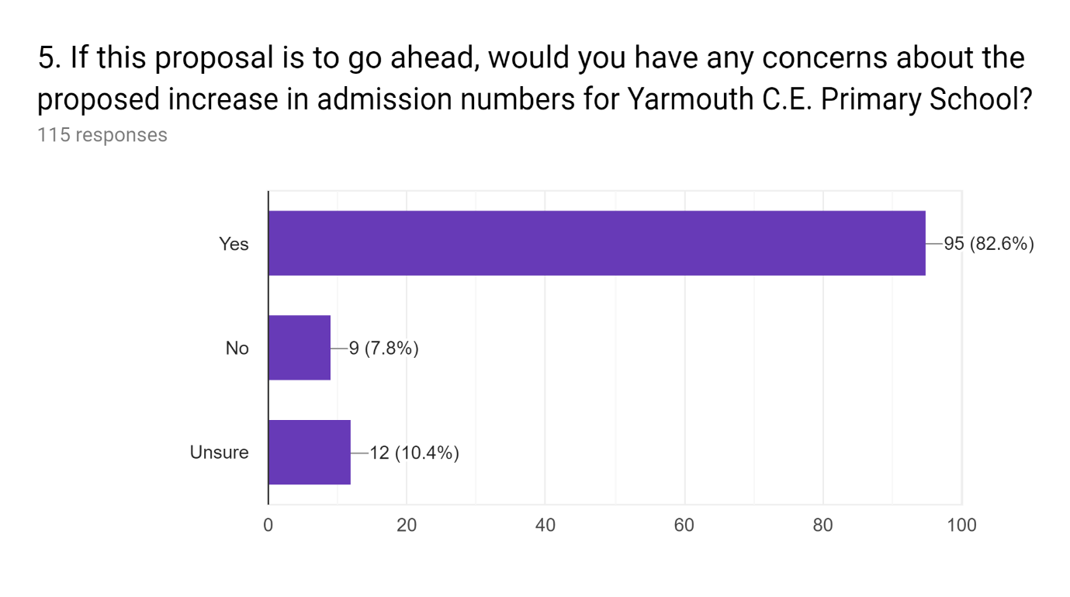

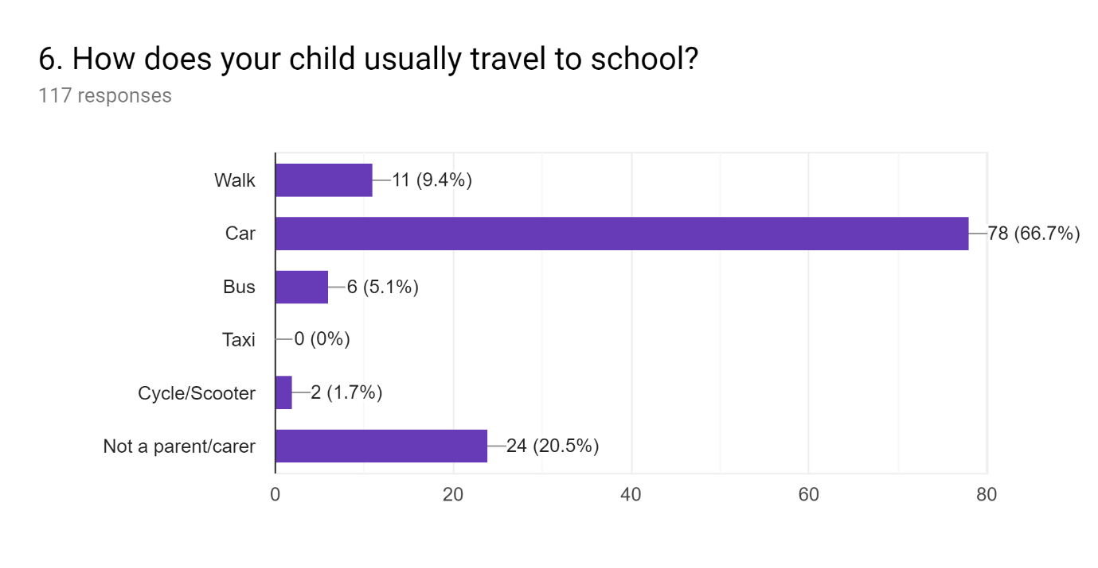
8. What other proposal would be your preferred option, as per the consultation document. Or do you have a new option you would like to be explored? *
*Please note: Respondents could select more than one option

The closure of All Saints' C.E. Primary School and expansion of St Saviour's Catholic Primary School to 1 form of entry.
The closure of All Saints' C.E. Primary School and allow the admissions process to manage the impact of reduced places in the area
That no change is pursued and the current situation is allowed to continue
Closure of both All Saints' C.E. Primary School and St. Saviour's Catholic Primary School and seek to open a new 1 form of entry free/academy school on one of the existing sites.
The closure of St Saviour's Catholic Primary School and expansion of All Saints' C.E. Primary School to 1 form of entry
For a wider investigation that looks into the wider infrastructure of a schooling, housing and industry to do the right thing for our West Wight community in its entirety
Honestly, I am not sure. I will support in anyway I can. I want the best for the children and the staff of the federation who work tirelessly for our children. I wish there was a nice option for all involved.
I would prefer no change, but for the concern that if nothing changes, Yarmouth school will eventually be too small to be viable. Population in Yarmouth is not likely to go up, where as freshwater is. But even with that population as a whole is dropping, so the larger schools have more of a future. I however do not think that a primary school should be larger than 250, including staff.
No other suggestion
Closure of All Saints and reduction of Brighstone PAN to completely cover the reduction of spaces required
That All Saints staff, governors, and head teacher all be sacked and replaced. All saints should then be federated with Yarmouth and Shafleet under their leadership
The closure of Brighstone and moving their pupils to All Saints. People living there have means of travel, and can afford to.
I don't know the answer but I feel In the best interests of the children of both schools the 2 schools should remain open but All Saints should have a new leadership and management structure put in place.
Why disrupt our excellent school when there are two more simple options We are paying the price of being under threat just to serve and save the school that 81 children go to because the community of freshwater don’t want to lose their school, we we as part of the community of Yarmouth (which we are as the school bonds the community) do not want to lose the school in Yarmouth. The idea in itself is ludicrous
All saints school should close like originally proposed as it is ultimately a failing school. There clearly isn't enough parents in the West Wight area who would choose to send there children to that school- this has been proven in the massive decline of children wanting to attend this school. The children's education should be the main consideration when choosing which school should be closed. Yarmouth federation with Shalfleet school works well and has been ofsted rated good. The pupils who have attended this school are all doing well and achieving good grades. All saints has been underachieving and not achieving such high grades. If you are to move the children temporarily to Yarmouth and then relocating all children back to all saints new school that will be causing disruption to two schools pupils education rather then just one. If all saints is to close the parents of all saints pupils should be offered choice and be able to choose between the 4 remaining schools in the west Wight area that they would like to attend.
Keep all schools open, federate brighstone with all saints and keep the children undisturbed and help support improvement in the schools
-Close All Saints’ CE primary school at the end of Summer Term 2020 -In time for the beginning of Autumn Term 2020; open a new, non-denominational school for Freshwater on the site currently occupied by All Saints’ under the leadership of a new board of governors & Head Teacher with a per year PAN of 15 -Reduce Brighston CE Primary School’s per year PAN to 20 and restructure the year groups & school infrastructure accordingly.
All saints could thrive again with a new team in charge ,moving everyone about is not the answer
The closure of non performing schools only and build a new one ie all saints and brighstone
The closure of All Saints and the children to be distributed between the other four west wight schools of their choice
My prefered option is to close All saints school and to distribute the children between the four remaining schools offering them the choice of which one. OR combine the two undersubscribed schools-brighstone and all saints. Leave yarmouth school in yarmouth
No change to the schools, but the issues that have arise. At Freshwater school be addressed, maybe the teaching and the site be improved to make it a more attractive and successful school for parents to want to send their children to. New homes are being build nearby.
Combine brighstone and all saints as both failing schools or just close like you did weston
I have every faith in Miss Granger to do the right thing and I have confidence in her team. I am worried about the disruption for the children and there is a reason i drive to yarmouth each day rather than walk the 40 0 yards to all saints. I want a good education for my childeren.
Look at the reasons All Saints has had a vast reduction in children and look at ways to improve this to make it a thriving school again
Managed adjustment of PAN across the West Wight to significantly reduce PAN surplus. Aim to keep all local schools open for long term benefit of the communities, not based on 5 year plan.
Why not just improve all saints and Brighstone which are failing schools. Or combine all saints and Brighstone which are the problems area
Parents will continue to have choice.

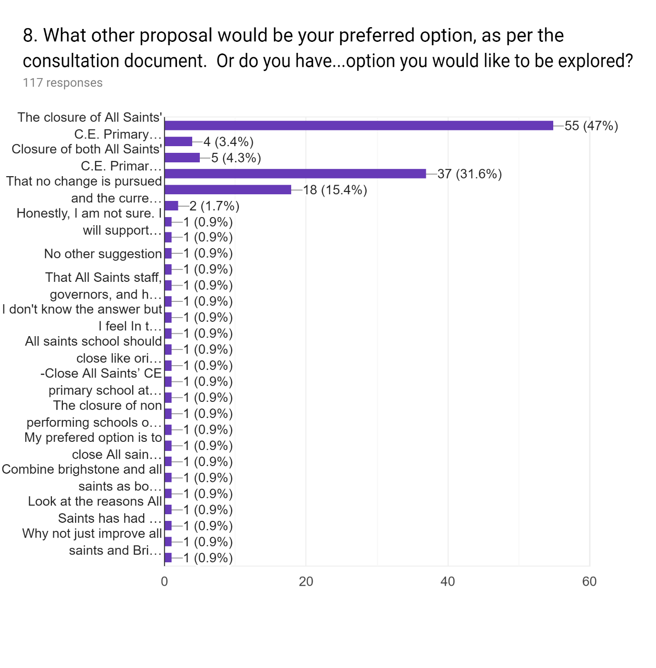
Key
- The closure of All Saints' C.E. Primary School and expansion of St Saviour's Catholic Primary School to 1 form of entry.
- The closure of St Saviour's Catholic Primary School and expansion of All Saints' C.E. Primary School to 1 form of entry
- Closure of both All Saints' C.E. Primary School and St. Saviour's Catholic Primary School and seek to open a new 1 form of entry free/academy school on one of the existing sites.
- The closure of All Saints' C.E. Primary School and allow the admissions process to manage the impact of reduced places in the area
- That no change is pursued and the current situation is allowed to continue
- Other

