Shalfleet C.E. Primary School – Responses to the Consultation

Parent View - West Wight Consultation - LA new preferred option

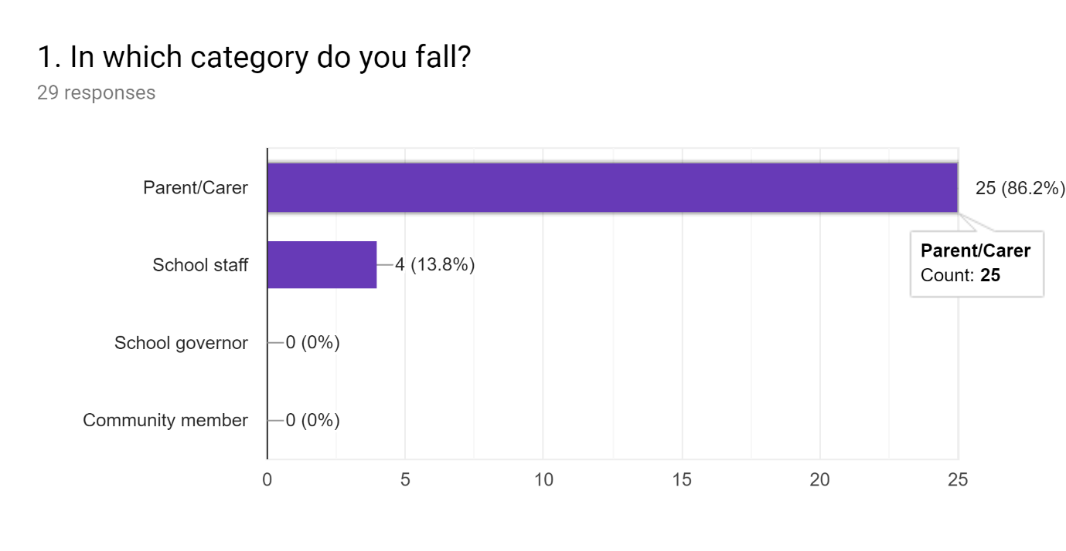

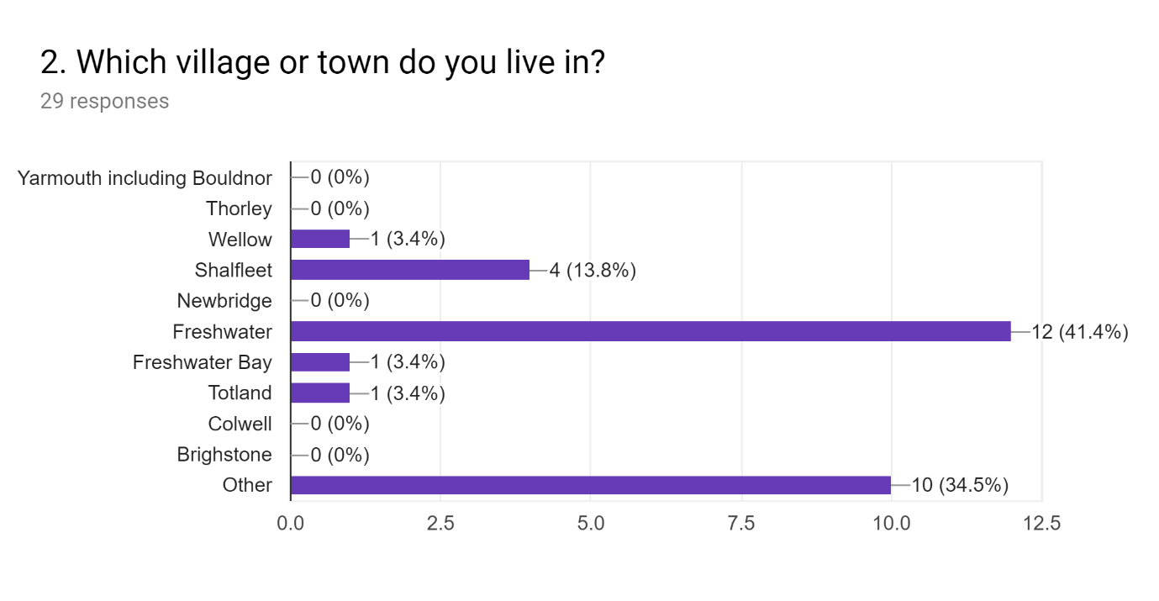
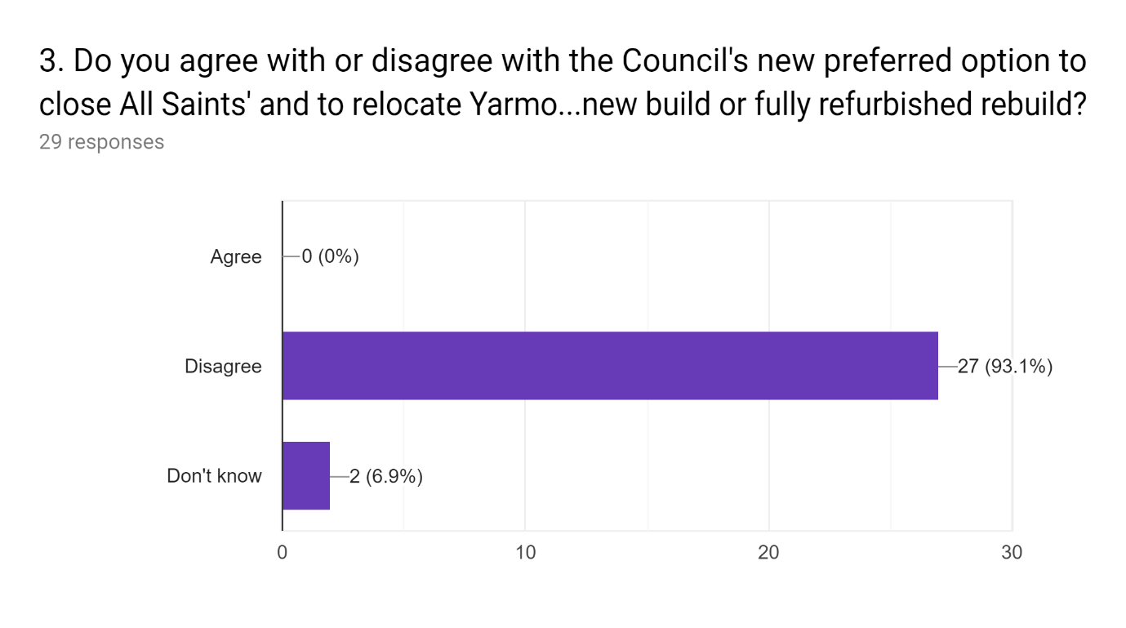
From attending the meeting on Wednesday at Yarmouth CE Primary School, it is apparent that the proposals put forward by the Council have absolutely no regard for the welfare, education and wellbeing of the children in West Wight. They see this as a paper pushing, tick box exercise of numbers and children should NEVER be regarded as this. I feel very strongly that a school (and Federation) which has worked tirelessly over the past decade to raise and maintain standards should not be penalised because of the failure of a West Wight school, in which decreasing standards and poor management have been allowed to continue for many, many years despite the pleas of staff, parents and some govenors. To say that Yarmouth School is not being closed as part of this proposal is simply semantics. In relocating it you are closing it and stripping it of its wonderful community and amazing location which is used so much in the education of our children - to give them a broad and fun curriculum. I understand that the pot of money allocated for a redeveloped school/new school is only for use on the All Saints Site but money should not be the determining factor in this - children's education and wellbeing should be. It makes no sense to relocate - unsettling the whole school ethos, practice and ultimately the education of the children. Should we need to take in more pupils, we should at the very least strive to keep the Yarmouth site and avoid the unnecessary discomfort for all concerned with a relocation.

Yarmouth school is in the heart of the community, I feel it will be detrementle to the children in yarmouth who need continuity. Also parents choice needs to be concidered, parents who choose not to send their children to the larger All Saints site shouldn't be forced to.

Absolutely disgraceful,, Yarmouth school is thriving and the reason people travel from freshwater to take their children to school there just goes to show what a bad reputation All Saints school has got,,, Yarmouth should be left how it is and All Saints closed.

People choose to send children to yarmouth based on its size and proximity to local people. It is a village school. Freshwater school serves a greater number of individuals. In effect moving yarmouth school to freshwater would in all sense and purpose be closing yarmouth and building a new school for the two combined schools. It is likely that Shalfleet would receive greater increase in applications onto a school site which has only just increased in physical size and does not really have options of further expansion. Travel by car would be likely to increase from yarmouth for most parents.

So short sighted; with all the new housing being built, closing schools is a ridiculous suggestion. These school places will be needed.

Why cant all saints relocate to Yarmouth school ? That's what is planned in the short term anyway, why not make that a permanent arrangement. Most freshwater parents already send their children to Yarmouth or Shalfleet already. It's only a small minority of 'parents' who want all saints kept open, BUT they don't want the building kept and the staff ? What do they want ? They want their cake and eat it, which is just unfair. If they really don't like all saints then just close all saints for good, ,sell the land, improve and extend Yarmouth school, and Freshwate parents who don't want to send their kids to Yarmouth let them send their kids to st saviours. Seems obvious, and would save the immense cost of building a new school on the all saints site. Don't shut a successful school, in a beautiful location, the centre of the community, (freshwater has a vibrant sports centre as it hub already), and relocate it at a huge cost. Look at the amazing refurb Shalfleet school has undergone for a relatively small cost in a short time scale. This could be done to Yarmouth. Freshwater parents who send their kids to all saints will never be happy with any decision made. Freshwater parents who send their kids to Yarmouth will accept and support changes to Yarmouth school like they have done already for years.

I still wouldn’t send my children to the school if they close and relocate Shalfleet was my preferred choice of school and my children are happy there and it is a good school.

1) There are a lot of houses just been built and probably going to be built in Freshwater. These houses seem like they are suitable for young families so there will be a future need for more school places in Freshwater in the future which could sustain All Saint's Primary. Once Yarmouth CE Primary is gone there will be no going back. 2) Unfortunately the LEA seemed to have allowed a situation to continue at All Saints over the past few years resulting in these low numbers. One might think that they were allowing it to continue to facilitate the process of the closure of a school. Whether All Saints was purposely allowed to deteriorate or it was just lack of action by the LEA it is now going to have a huge detrimental effect on one or both communities. 3) Yarmouth School has so many learning opportunities on it's doorstep. The firestation, the harbour, the beach, the railway track, the historical town, the castle, Fort Victoria, the Life boat and easy access to the ferry links. These are all free learning opportunities and within a short, safe walkable distance. These are not only able to be used by Yarmouth School Children but also makes it much easier and cheaper for Shalfleet School children to use them as well. 4) They say the refurbished school will still be called Yarmouth School - that is missing the point, it doesn't matter what it is called, it is the location that matters. 5) The data about the number of children attending Yarmouth school who live in Yarmouth is misleading as there are a lot more children living in surrounding area for whom the trip to a Freshwater School would be further or no different than Yarmouth. 6) Yarmouth School is important for the town itself..

Is All Saints the better site ? What about transferring and staying on Yarmouth site ? Qu 6 Use Ventnor as a model on how to combine religious schools and keep a broad schooling option available for the children and families of Freshwater

My nephew goes to Yarmouth and it allows me to pick up both my son (@3:15) and nephew (@3:00) as then are both on the main road from freshwater to Newport.

Doesnt make a sense,it’s too far away.

I believe a new head should be appointed at all saints as it seems the loss of numbers has come from her lack of leadership... We can not afford to increase numbers anywhere and put more pressure on both children and staff!! Development sites are in progress in the west wight where will these children go!!??

Yarmouth is a school which is performing well with a good number of students. Why would you change something that is working. You should fix a problem not a success.

I believe it is outrageous to disrupt two schools plus a third school associated via federation. If the decision has been made to close all saints then all students should relocate where they can instead of causing further disruption to other children, families and staff.

Yarmouth is such a fantastic school, with a wonderful nursery, re locating this school would rip the heart and soul out of Yarmouth, the school is thriving and has done for many years! I was a pupil in the late 90’s and it’s a school that stays with you into adulthood. The traditions and links to the community are so strong and so unique that they are still continued to this day and go back decades. My son attended the pre school and they were absolutely fantastic with him, he went from strength to strength there! I live in freshwater and have chosen to send me children outside of that town because it does not hold the same commute spirit and warmth that Yarmouth and shalfleet do. I also now manage a very successful coffee house in Yarmouth and it would also have a huge impact on small local businesses that depend on the parents and teachers of Yarmouth passing through Dailey! I cannot stress enough how damaging this would be to the whole town!

This option would be disastrous for yarmouth, the school is the heart of yarmouth. My wife attended in the late 90’s and her parents before that. The school is an absolute fantastic school, and thriving how it is. Moving the school would not only be absolutely devastating to every child and parent there, but to the town itself. Yarmouth relies on the parents, teachers, children passing through to keep the local businesses afloat, removing the school would kill the town and it would end up a ghost town for most of the year! Having worked in yarmouth myself I can’t stress enough how much the locals are needed out of the summer season! The school is achieving great results and the children are happy. This move would be catastrophic for the children’s mental health and educational health, it is unnecessary and avoidable. Please re consider and think of how hard people have worked to keep that school alive!

The total disruption Will only have a detrimental effect on all childrens education. This option Will not address the problem of surplus primary school places in the West Wight. Removes choice from parents to where they want their children to be educated. The removal of the school Will have a massive impact on the small community of Yarmouth.

I'll thought through, it can only bring undue & unnecessary stress for all the children & their education. Makes no financial sense, and it still doesn't address the surplus primary school places in the West Wight. It removes the school from the Yarmouth community which will have a massive impact.

As a parent of children who came out of all saints school, I will not send my children to that site in future and am not the only parent of children at the federation to say the same as we all moved and it wasn’t nice and now are happy where our children go. Also I am a parent of a child who goes to little stars pre school as I find this the best pre school . As a parent and a childcare practitioner I can say it will be a massive loss to lose that pre school . My eldest went to yarmouth primary from all saints and did so well , I went there as did my mum , uncle and family members and certain traditions still carry on now from all those generations that will be lost plus it has a community link like most other schools do not have . Plus also If the head of all saints at present gets any form of job in the federation if this went ahead I would take my children out from what she caused to all our children parents and her staff in the past .

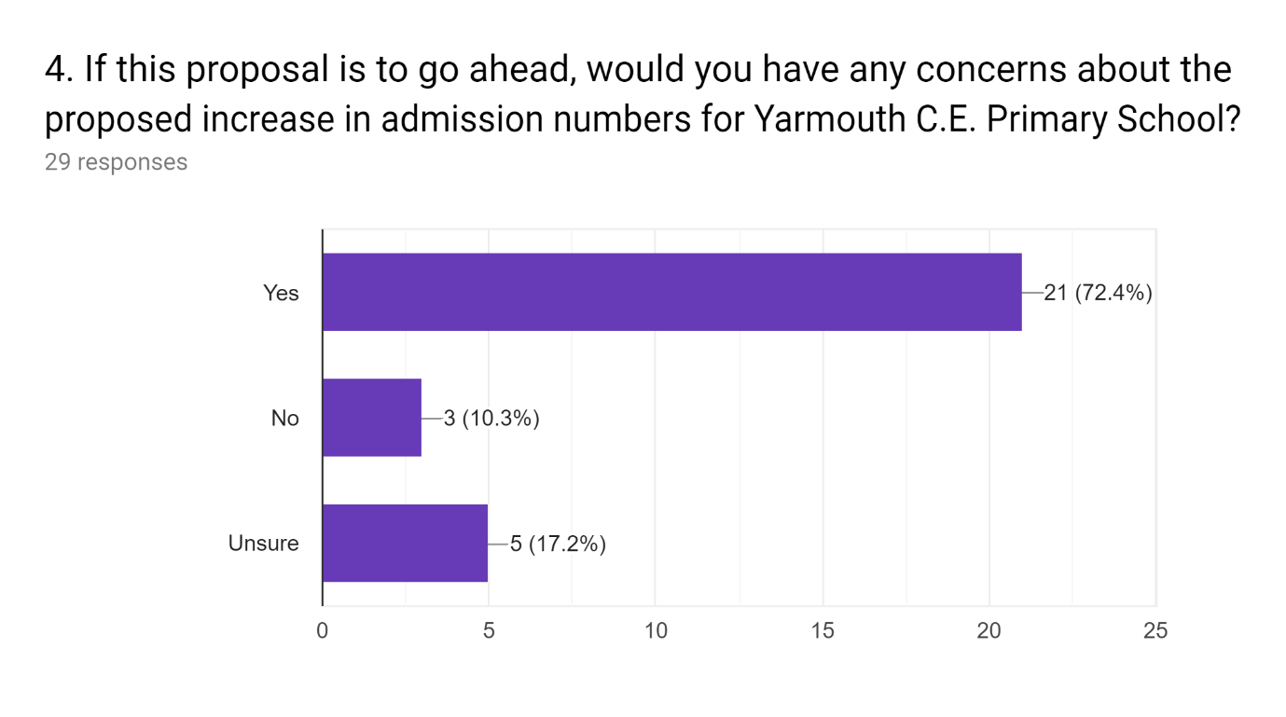
Staff are already pushed to the very limits of their capacity. With staff reductions and reductions in hours, most members of staff wear several hats and are working at their limit. Children with SEN and high needs are managed currently but there is not the capacity in school to help further children with SEN needs. 1:1's are already satelliting and looking after more than one child. When a member of staff is off sick at the moment or called away it is hard to fill the void this creates. Resources are also extremely limited with many staff members using their own money to pay for items to equip their classes. This is happening with a PAN of 15 children per year. If you double this imagine the chaos and the pressures you are placing on a team already working at its limit. Think also about the children - after all this is who we do our job for. This proposal gives all children concerned a very unsettled year, working in classes with changing children, too small classrooms, poorly resourced classrooms - huge disruption. Some of these children have already had a great deal of disruption with the close of Weston Academy. I am also incredibly concerned about how at least a year of chaos will present in the children's and ultimately school's attainment - data should not be the only factor in determining a school's success but we know it is the biggest factor. The school's data will take a long time to give a true representation of the fantastic work of the school and knowing we will be in the Ofsted window - well they won't give any regard for whether we are a school that has undergone great change. I don't believe the LA will support the school once they have ticked their box and reduced surplus places in West Wight. One additional point is that our PAN of 15 in Reception provides our school with a very special capacity to invest in our children and families in their first year of 'big' school. We work very hard to transition children in - children with every increasing additional needs. Parents choose Yarmouth School because of our ability to give each child the time they need to settle into school life. We invest so much into our families at this early stage which builds the foundations for their journey through our school. Staff are not going to be able to nurture in the same way if the cohort is doubled, knowing that the level of SEN and additional needs we will be receiving will be high.

The reason it works is because they have small numbers, some children that attend wouldn't be able to cope in a larger school. It is also parents choice to choose a small school in the village if they want to.

Absolutely, this will have a massive impact on the children’s learning.

I consider it more likely that shalfleet will receive higher applications in a bid to maintain that village school feel for most parents

for a start if the school was in freshwater it would NOT be Yarmouth primary. If it was on the old all saints item it would be all saints and that's what people would call it, irespective of dfe number. If birth rate is truly falling in freshwater then why create something bigger only to make it smaller in years to come ? Why not make the Yarmouth school a more flexible sized site, with classrooms that can be merged or partitioned to allowed future growth or decline. Surely building a larger school now for the current population will only require other smaller local schools to close in years to come to help keep the newly built larger school to be viable. Please think ahea

If it is to go ahead the situation will only be temporary. The newly refurbished school should be built with enough spaces and room to extend if needed. We may find that many parents choose to send their children to another school all together to avoid a year of disruption in their child's schooling. Shalfleet or Brighstone or St Saviours.

If 2000 homes end up being built in Wellow admission numbers will need to increase in the area.

It will affect the metal well being of both Yarmouth and All Saints children there and in future as well as the physical affects of space in the building and field.

The head teacher is stretched enough leading two schools when adding in the children from all saints I cannot see how this is possible with no effect on the children within her care.

The increase in admission numbers Will require the closure of ANOTHER school in the West Wight to address surplus primary school places!.

I believe this will in the long term facilitate the need to close another primary school in the West Wight.

Yarmouth is a unique school it’s a nice size and cannot an extra 70 or 80 children onto its grounds, where would children then play and how would it be a good learning environment. Plus as a federation the head is doing an amazing job but if it were to increase in numbers and the distance between schools increase how would this work for her we all would see her even less .

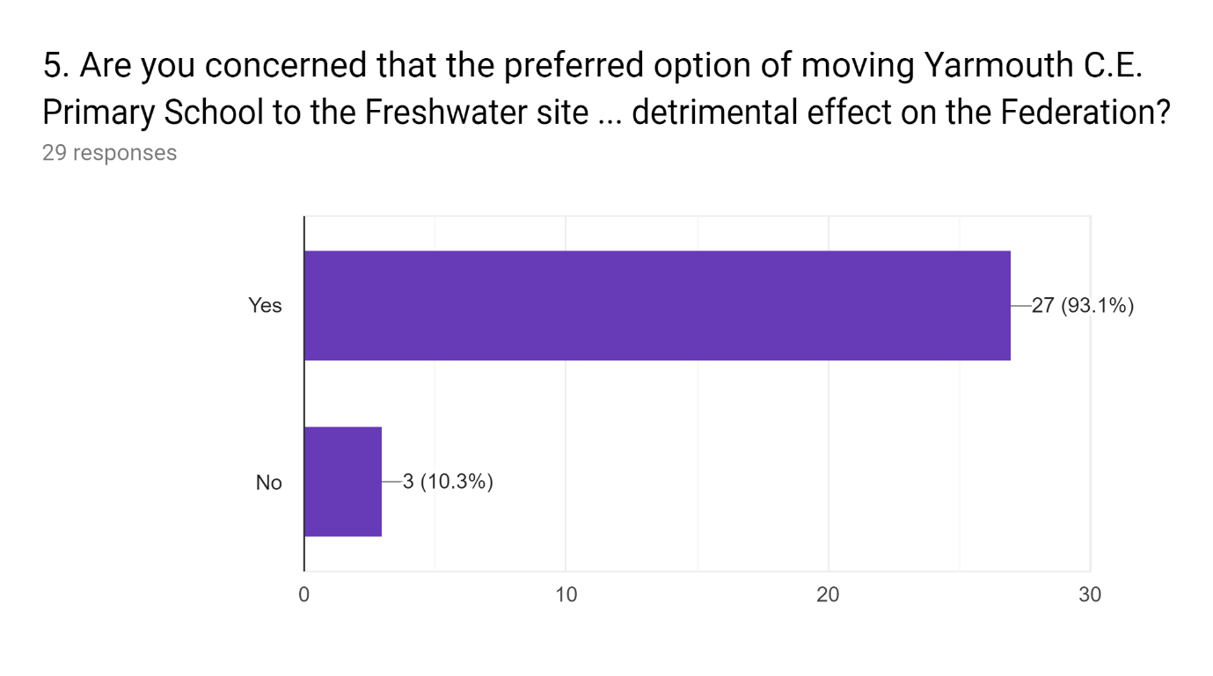
I think we need to look at the long term implications of this as well as the immediate effect. Even the proposal is having an impact on the Federation with parents already incredibly unsettled and looking to 'jump ship.' The logistics of further distance between the 2 sites of the federation would not be ideal - the extra stretch on senior leads and management would be detrimental to the wellbeing of the federation. Also, long term - if an outstanding/good school is created on the All Saints site - which I have full faith in our team to do through blood, sweat and tears - I believe you would see a significant drop in pupil numbers at Shalfleet - Freshwater families would use their nearest school if they both offered good provision.

The Yarmouth and Shalfleet share alot of extra curricular days involving the community that wouldn't be possible if yarmouth school was no longer in yarmouth and increased to the size required for the All Saints site.

Moving children will only effect their learning and leave gaps in their education.

Why should Yarmouth, a successful school, be penalised because of a failing school? Invest (not just financially) in All Saints and get it performing well

Whatever the stance of the teaching staff and leadership team of the federation at this time, they WILL UNDOUBTEDLY be stretched both by time and resources to cope with the proposed merger with an intake of underperforming kids.it is a FACT that when children move school their development is halted by at least 6 months, so add this to a cohort/influx of underperforming kids and Yarmoutb WILL go from a good school to an RI school, itsinnevitable. Good staff from Shalfleet will be moved accross the site to manage this, and then Shalfleet will go from a good school to an RI school. Our current head is fantastic BUT is only a relatively new head, how will she cope with the extra pressure, and we may lose our amazing deputy head in the next year or so to retirement, how will this affect the leadership team ? Newish head, potential new deputy, huge new site, influx of underperforming kids = stress, fracture, and failure in the short term. The LEA will get slated for it.

I feel both schools are thriving well led by Mrs grainger and teams at both schools.Both schools have good ofsted and reputations children are happy and learn well.We as parents made the decision based on our children’s happiness in visiting the schools and on how well they do we were prepared to travel to shalfleet daily. This would not change our minds and will be leaving my children in shalfleet primary even though we live in freshwater and it is near.

I wish there had been an unsure box for this answer too. 1) The extra distance will affect things, maybe not in a huge way but it will have an effect for SLT moving between school and teachers too for staff meetings. Is there a travel allowance to be considered? 2) There will be a much larger intake for the federation, that will also have an effect but Shalfleet/Yarmouth have a strong SLT who are very good at developing a clear vision so hopefully will be fine. 3) how will school budget be affected in this interim period? How quickly will the money come through for the extra children? How will the budget be managed for All Saint's in the first term? will some of it be withheld? I'm sure you're all thinking of this too.

Other federations on the Island are further apart geographically.

I can not see how the federation will continue if this preferred option goes ahead!!

It would without doubt become the priority due to it being 2 schools combined and with the high profile surrounding the situation would have all the focus on it. Shalfleet would suffer.

As a parent of a child at shalfleet, I 100% believe this would have a negative impact on the federation, the two schools work so unbelievably well together, making this further apart and even more pupils to account for would definitely strain the staff. Both Yarmouth and shalfleet are thriving schools as they are, it seems so heartbreaking to me that anyone would want to throw all of this in the air and damage something so wonderful!

Yes this will definitely have detrimental effects on the federation! The federation works so well because the two schools are close together, and smaller in size, both schools are doing fantastic as they are, the teachers work so well together and it all works well, I think moving the schools further apart and having the teachers take on even more pupils would have such a negative effect on how they work. We live in freshwater and purposely chose shalfeet and yarmouth as our two choices.

There Will be no Community connection between Yarmouth and Shalfleet , there will be no inter school activities because of the extra distance. The Councils school improvement team have not managed to overcome All Saints difficulties over the last decade including investing considerable time and money. To expect Yarmouth Schools leadership team to achieve what they couldn't as well as the disruption of moving 80 children(twice), moving a whole school and managing a new build/major refurb Will without a doubt affect the federation.

It will remove the community connection between Yarmouth and Shalfleet, the distance will impact on the inter-school activities. The pressure on the head teacher / teachers and governors to take on 80 extra pupils, school relocation and new build would have a detrimental effect to Shalfleet school.

Extremely concerned, firstly any cake to yarmouth and shalfleet from all saints school in not nice circumstances and do not want to and will not go back to that site . Also how can it then have its governors from yarmouth and it’s parish council from yarmouth and it’s church from yarmouth and it’s links with yarmouth when it’s not in yarmouth. Plus after this casing such a rift between the schools how can it be good to then place them under one roof including staff who were there and part of the problem at all saints .

6. *
Key
- The closure of All Saints' C.E. Primary School and expansion of St Saviour's Catholic Primary School to 1 form of entry.
- The closure of St Saviour's Catholic Primary School and expansion of All Saints' C.E. Primary School to 1 form of entry
- Closure of both All Saints' C.E. Primary School and St. Saviour's Catholic Primary School and seek to open a new 1 form of entry free/academy school on one of the existing sites.
- The closure of All Saints' C.E. Primary School and allow the admissions process to manage the impact of reduced places in the area
- That no change is pursued and the current situation is allowed to continue
- Other
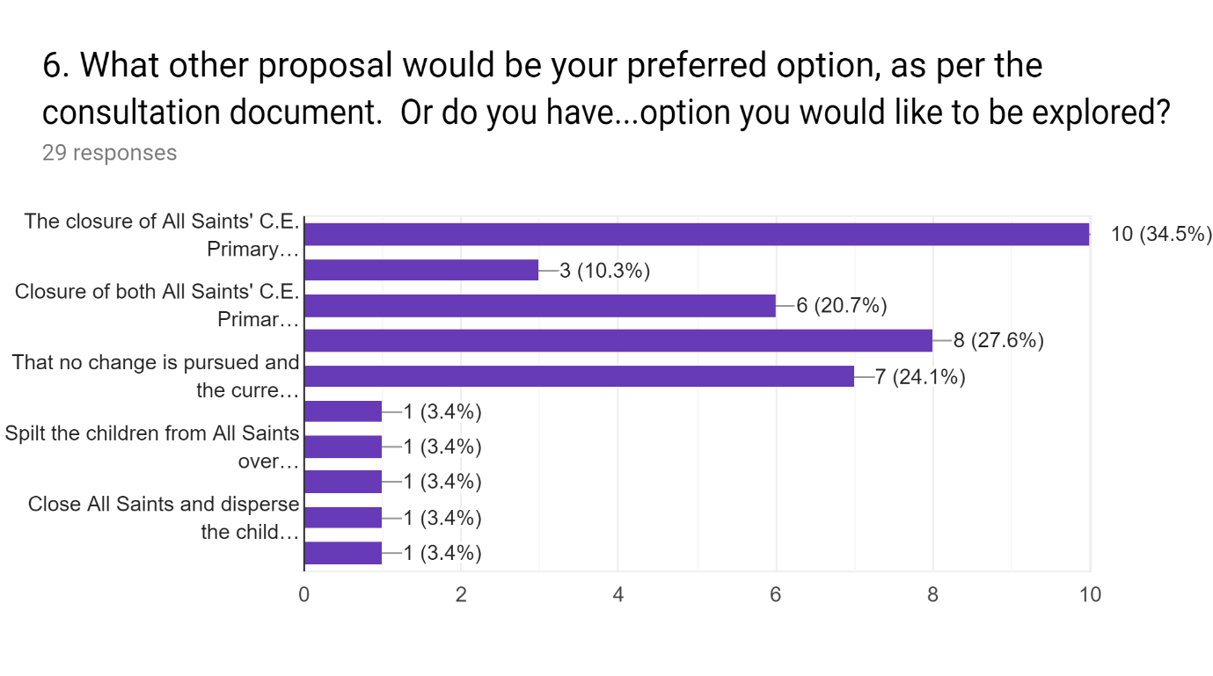
*Please note: Respondents could select more than one option.

