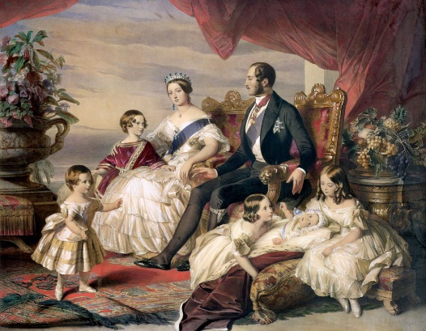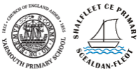

Our first half term RE focus is the concept of Special through the theme of Special Books with particular focus on the Bible and the Torah,

Next half term we will be learning about the concept of Light as a symbol through Advent and Hanukkah.

**Social** – Teamwork within class, particularly through the unit of work on ‘Here We Are’.

**Cultural** – Looking at aspects of local, Victorian history.

**Moral** – Looking at Victorian values

**Spiritual** – Constant referral to issues around spirituality in worships (class and whole)

We will be looking at E-Safety for our first computer sessions along with simple coding and instructions. We will be using technology to support our learning in a range of different ways; including taking photos and videos.

During the Autumn term, we will be recapping some previous learning to ensure the foundations of Place Value understanding are secure by counting, sorting and comparing groups of objects and numbers. We will move on to working with number and place value by adding and subtracting using whole-part models, number lines and place value charts.. Autumn 2 is when we will be looking at Geometry and Shape and consolidating the place Value learning as we go.

Our focus texts for this term will be Oliver Jeffers’ ‘Here We Are’ and ‘The Lost Words’ by Robert MacFarlane. Here We Are is a wonderful guide to living on planet Earth and we will be working towards building our class relationships and writing our own guides to living ‘Here’. The Lost Words is a stunning book of poems dedicated to ancient words like ‘dandelion’ and ‘bramble’: the words that are sadly being lost from our children’s vocabulary. We will celebrate our environment by creating our own poetry about what’s living around us.

We will be identifying and exploring everyday materials. We will identify and compare the suitability of a variety of everyday materials, including wood, metal, plastic, glass, brick, rock, paper and cardboard for particular uses, Our science learning will also take us outside into our school environment as well as exploring materials during our weekly forest school sessions.

Our key area of learning this term will be in History where we will be learning about significant individuals and events from the past. Queen Victoria and her family home at Osborne will be our main focus, along with looking at what life was like for children and some famous Victorian inventions. We will be plotting key events on timelines and comparing her reign to that of Queen Elizabeth II. Our learning in geography will focus on completing a study comparing the Isle of Wight. We will develop knowledge of the location of significant places in the context of children’s own locality.

Taking Covid restrictions into account we will be learning, P.E. lessons may be a bit different for a while. We will be practicing ball skills, paired work and sports within our class ‘bubbles’. We will also be doing weekly forest school sessions.

We will be learning about the work of famous, notable artists and designers. We will use inspiration from Andy Goldsworthy and William Morris to create their own work and compare.

art and design techniques.

In order to understand how Victorian inventions have influenced our lives we will be making our own pinhole camera following a Victorian design. We will evaluate the end result and suggest ways to improve.

Due to restrictions from Covid we are unable to have trips or visitors but we are planning on having a risk day for the children which we will announce during the term.

There will be weekly homework in Spelling and Maths. The work will go home each week in homework books and you can keep in touch with your class teacher via Class Dojo or the class email for support.

Daily phonics will take place working within the phases appropriate. We will be reviewing, consolidating and teaching graphemes, cvcc words and tricky words.

We will listen to music and identify when it changes e.g. changes speed, volume sounds sad/happy and discuss how a piece of music they have listened to makes them feel and what they think about it.

**TOPIC TITLE**

**YEAR _**

**AUTUMN 2020 - 2021**

**Victorian Values and Invention**

**YEAR 1/2**

**AUTUMN 2020-2021**

**FOCUS CURRICULUM PRINCIPLES - (1) Broad, Relevant and Balanced.**

**(2) Valuing all children, learning is accessible to all.**

**HOMEWORK**

**COMPUTING**

**PE**

**PHONICS**

**PSHE/SMSC**

**RE**

**MUSIC**

**DT**

**ART**

**TRIPS/VISITORS**

***KEY AREA OF LEARNING*** - **GEOGRAPHY/HISTORY**

**MATHS**

**ENGLISH**

**SCIENCE**