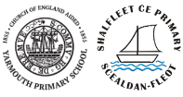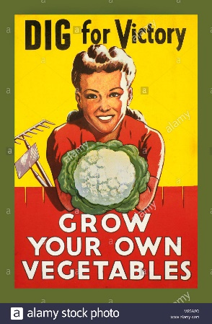

We are going to be focusing on ‘Way Home’ which is a picture story book about a homeless boy and life on the streets. The books lends itself to a range of writing opportunities which include writing from a different perspective and writing persuasive letters There will also be opportunities for diary writing and a discussion text about the characters. We will also be creating a non-fiction piece about homelessness.

Our key area of learning this term will be history - a study of British history beyond 1066: WW2 focus. The children will be ordering historical events on a timeline; describing, in some detail, how the Isle of Wight changed during WW2; reflecting on different viewpoints (attitudes and beliefs of men, women and children by looking at the blitz, evacuation and fighting) and understand the difference between primary and secondary evidence.

We follow the Hampshire ***Living Difference III***. In the first half term we will look at Jesus the law breaker – learning about law and Jesus’ relationship with it and then at the end of the term we will learn about prophecy through the Magi and birth narratives.

We will be learning wartime art, in particular the posters found at this time: ‘Careless talk costs lives’ as well as paintings depicting war using mixed media.

During this term we will be focusing on asking and telling the time, recapping simple greetings and phrases about us and our families. Finally, we will be writing postcards.

**School Value: Determination**

**Social** – Teamwork within class, working with each other in our topic lessons, particularly when making war time food recipes.

**Cultural** – Looking at British history & how the World War changed Britain & our relationships internationally.

**Moral** – Looking at the moral implications of the choices made both sides of the War.

**Spiritual** – Constant referral to issues around spirituality in worships (class and whole)

Spelling/PAG homework will be set weekly. In maths, there is an expectation that times tables will be practiced during the week and online EEdi/ Diagnostic questions will be set up to be completed weekly.

**WW2 – Dig for Victory**

Year 6

Autumn 2020-2021

Focused curriculum principles - Challenging, engaging, motivating, High quality outcomes, deep learning

(2) Valuing all children, learning is accessible to all**.**

We will be using the theme of World War2 for our music this half term. And identifying & discussing influential composers in music history (Vera Lynn/Glenn Miller)

Our main focus will be on ***number*** starting with place value & being able to compare, order & round numbers to ten million. We will then explore the two relationships of +/- & x/÷, introducing long division and ensuring that concepts & not just procedures are understood. We will recap efficient methods at every step. We will solve multi-operation questions & investigate prime, cube and square numbers. For the remainder of the half term, we will be working with fractions, calculating with them: adding, subtracting, multiplying & dividing & gaining a deeper conceptual understanding of these rational numbers.

Light – We will use the idea that light travels in straight lines to explain: how objects are seen because they give out or reflect light into the eye; that we see things because light travels from a light source to the eye or from light sources to objects & then to the eye & why shadows have the same shape as the objects that cast them. Investigations will include looking at why/how shadows change size and investigating pinhole cameras to understand how the eye interprets what it sees.

**TOPIC TITLE**

**YEAR _**

**AUTUMN 2020 - 2021**

Along with two E-Safety sessions at the beginning of the half term*,* we will be learning how to edit photos in the style of WWII posters, recognise why a PowerPoint presentation is not effective and then edit it in order to improve it.

Taking Covid-19 restrictions into account, we will be learning a range of tag rugby skills at the beginning of term, moving on to practicing for cross-country and then finishing the term with basketball. We will also be doing weekly ***Forest School*** sessions.

Using our WW2 theme, we will design & build a bomb shelter that can withstand a ‘blast’. It will be decorated using mixed media for display. We will then test it.

Due to restrictions from Covid-19, we are unable to have trips or visitors but we are planning on having a risk day for the children which we will announce during the term.

**HOMEWORK**

**COMPUTING**

**PE**

**FRENCH**

**PSHE/SMSC**

**RE**

**MUSIC**

**DT**

**ART**

**TRIPS/VISITORS**

***KEY AREA OF LEARNING*** - **GEOGRAPHY/HISTORY**

**MATHS**

**ENGLISH**

**SCIENCE**