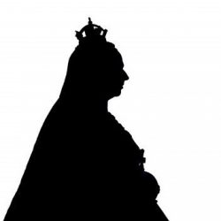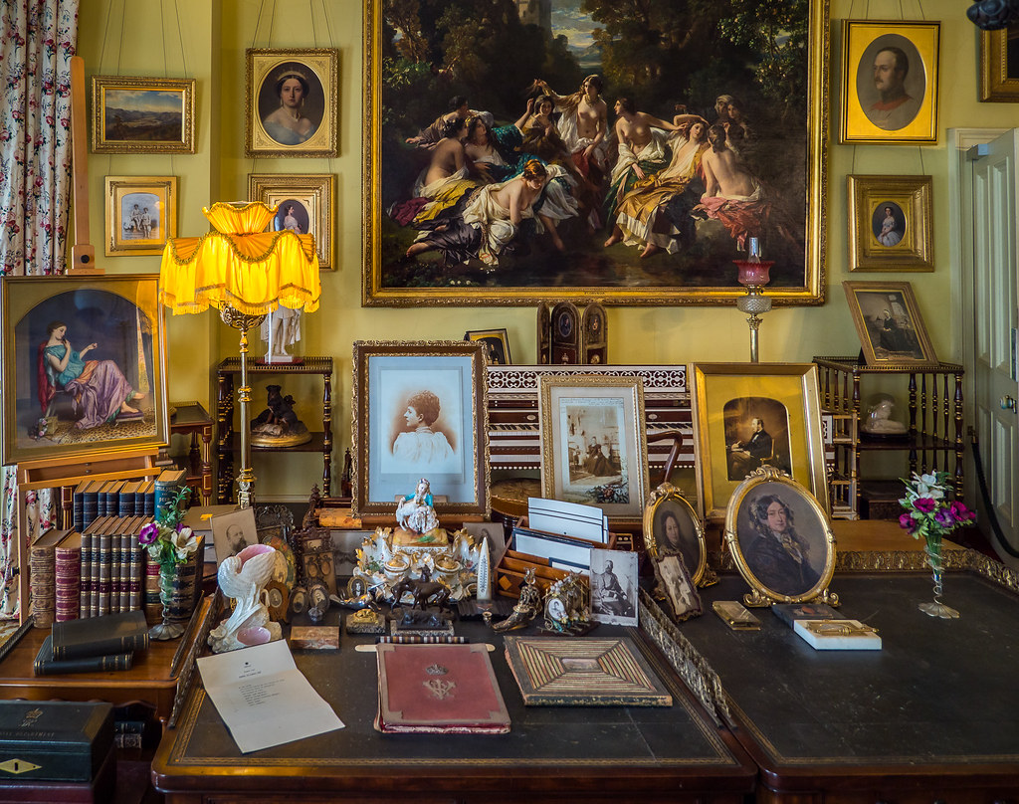 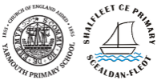

In Art we are focusing on painting and printing. To start with we are going to explore colours and texture. We are then going to use the artwork in Osborne House and famous portrait artists to inspire our own portraits of people.

We will listen to music and identify when it changes e.g. changes speed, volume sounds sad/happy and discuss how a piece of music they have listened to makes them feel and what they think about it. We will also be exploring rhythm and clapping and chanting rhythms finding out about long and short sounds.

We will be identifying and exploring everyday materials. We will identify and compare the suitability of a variety of everyday materials, including wood, metal, plastic, glass, brick, rock, paper and cardboard for particular uses, Our science learning will also take us outside into our school environment as well as exploring materials during our weekly forest school sessions.

Our focus texts for this term will be Oliver Jeffers’ ‘Here We Are’ and ‘The Day the Crayons Quit by Drew Daywalt.. Here We Are is a wonderful guide to living on planet Earth and we will be working towards building our class relationships and writing our own guides to living ‘Here’. The Day the Crayons Quit which has the illustrations drawn by Oliver Jeffers will be our focus on how to write letters. We will identify different uses of letters and their features before we have a go at writing our own letters.

.

During the Autumn term, we will be recapping some previous learning to ensure the foundations of Place Value understanding are secure by counting, sorting and comparing groups of objects and numbers. We will move on to working with number and place value by adding and subtracting using whole-part models, number lines and place value charts.. Autumn 2 is when we will be looking at Geometry and Shape and consolidating the place Value learning as we go.

In DT we are going to look at Victorian inventions. As a class we are then going to look at a pin-hole camera and come up with a design. We are going to decide what will be the best materials to make it and then make one!

Our first half term RE focus is the concept of Special through the theme of Special Books with particular focus on the Bible and the Torah,

Next half term we will be learning about the concept of Light as a symbol through Advent and Hanukkah.

Our key area of learning this term will be History. We will be Looking at significant historical events, people and places in their own locality. We are going to use the Isle of Wight as our inspiration and focus on Queen Victoria and Osborne house and her life on the Isle of Wight. We will also learn all about Queen Elizabeth II to. We will learn all about their lives and they things that they have accomplished as Queens. We will then make comparisons between Queen Victoria and Queen Elizabeth II and find out what things are similar and what things are different about their reigns. In Geography we will also be focusing on the Isle of Wight, identifying local landmarks and highlighting geographical features as well as using maps.

**TITLE Victorious Victorians**

**YEAR 2- Sky Class**

**AUTUMN 2020-2021**

**FOCUS CURRICULUM PRINCIPLES** –

(1) Broad, relevant and balanced-Local, Mainland, Global

(2) Valuing all children, learning is accessible to all

(3) Promotes independence and curiosity

We will be looking at E-Safety for our first computer sessions along with simple coding and instructions. We will be using technology to support our learning in a range of different ways; including taking photos and videos.

Taking Covid restrictions into account we will be learning, P.E. lessons may be a bit different for a while. We will be practising skills and sports in a socially distanced manner. We will also be doing weekly forest school sessions..

For our PSHE to link with our School Value of relationships we will be discussing friendships and being kind to others. We will be doing circle times and identifying the actions that are right and wrong when showing kindness.

Due to current restrictions, we will sadly be unable to go on trips this term. However, we are hoping to have a virtual tour of Buckingham Palace and Osborne House instead.

There will be weekly homework in spelling and Maths. The work will go home each week in their homework books.

Daily phonics will take place working within the phases appropriate. We will be reviewing, consolidating and teaching graphemes, cvcc words and tricky words.

**TOPIC TITLE**

**YEAR _**

**AUTUMN 2020 - 2021**

**HOMEWORK**

**COMPUTING**

**PE**

**Phonics**

**PSHE/SMSC**

**RE**

**MUSIC**

**DT**

**ART**

**TRIPS/VISITORS**

***KEY AREA OF LEARNING*** - **GEOGRAPHY/HISTORY**

**MATHS**

**ENGLISH**

**SCIENCE**