Sources of Financial Support for Families
If you are experiencing financial difficulty as a result of the Corona Virus pandemic, the following are trusts and charities which may be able to offer support. Application processes vary – some require a referral from a professional, others are a direct application from the family/individual.
Please be aware however that they may be facing higher than usual demand with lower than usual staffing levels.
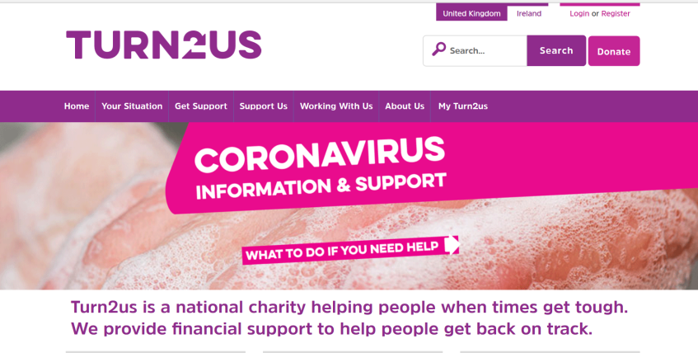
Turn2us
This is a charity that helps people in financial need to access welfare benefits, charitable grants and other financial help – online, by phone and face to face through their partner organisations. Their website has a wealth of information – including a benefits checker and a grants listing.

Glasspool Charity Trust -https://www.glasspool.org.uk/grants/who-can-apply
Giving small grants to individuals in need, which unusually, has no restrictions on the type of beneficiary. The usual aim of the grant is to help the beneficiary over a short term crisis. They do not accept applications directly from individual members of the public
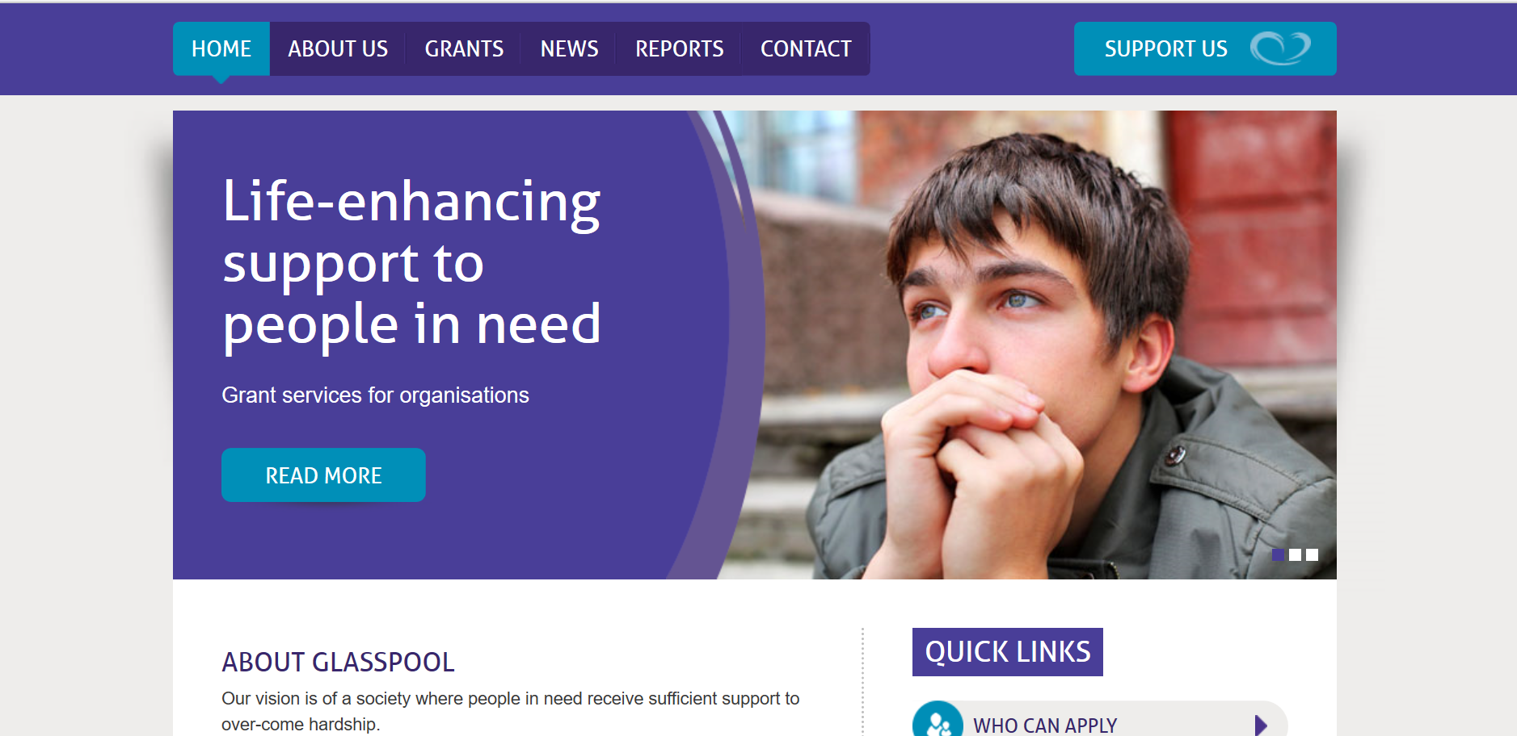
The Eaton Fund - Grants to those who are in need of financial assistance, to make a difference to quality of life, to enhance independence and/or to improve career prospects for artists, nurses & women.
They are a small charity however and ask for patience at the current time whilst they distribute their available funds.
------------------------------
Friends of the Elderly - https://www.fote.org.uk/
Grants available for home essentials, digital connection and general financial support. Must be managing on a low income with savings of less than £4000

-----------------------
Utility Bills
Many families may be struggling with or will struggle with utility bills – almost all of the main providers have funds for account holders which can support with bills and by providing household electrical items.
  - EON Energy Fund - helps pay current or final EON energy bill arrears. It can also help EON's most vulnerable customers by providing replacement household items such as cookers, fridges, fridge-freezers and washing machines – and also help to replace and repair gas boilers as well as e-learning vouchers
  - EDF Energy Trust - awards grants to individuals and families to clear electricity and gas debts owed to EDF Energy and to purchase essential energy efficient household items
  - npower Energy Fund
  - Scottish Power Hardship Fund
  - Ovo Energy Fund
  - SSE (Southern Electric) Priority Assistance Fund

British Gas Energy Trust offers grants and schemes that are open to anyone - you don't have to be a customer: British Gas Energy Trust
--------------------------
WW Spooner Charitable Trust
https://grants-search.turn2us.org.uk/grant/w-w-spooner-charitable-trust-16013?iframe=False&postcode=hd22as
Grants to individuals living in the West and North Ridings of Yorkshire. Grants have been given for helping the building fund of a new hall, clubs or homes for boys and the purchase of works of art for the benefit of the public. Grants also made to old employees of Spooner Industries Ltd. https://www.spooner.co.uk/ or their dependants who are in need.
-------------------------
National Benevolent Fund

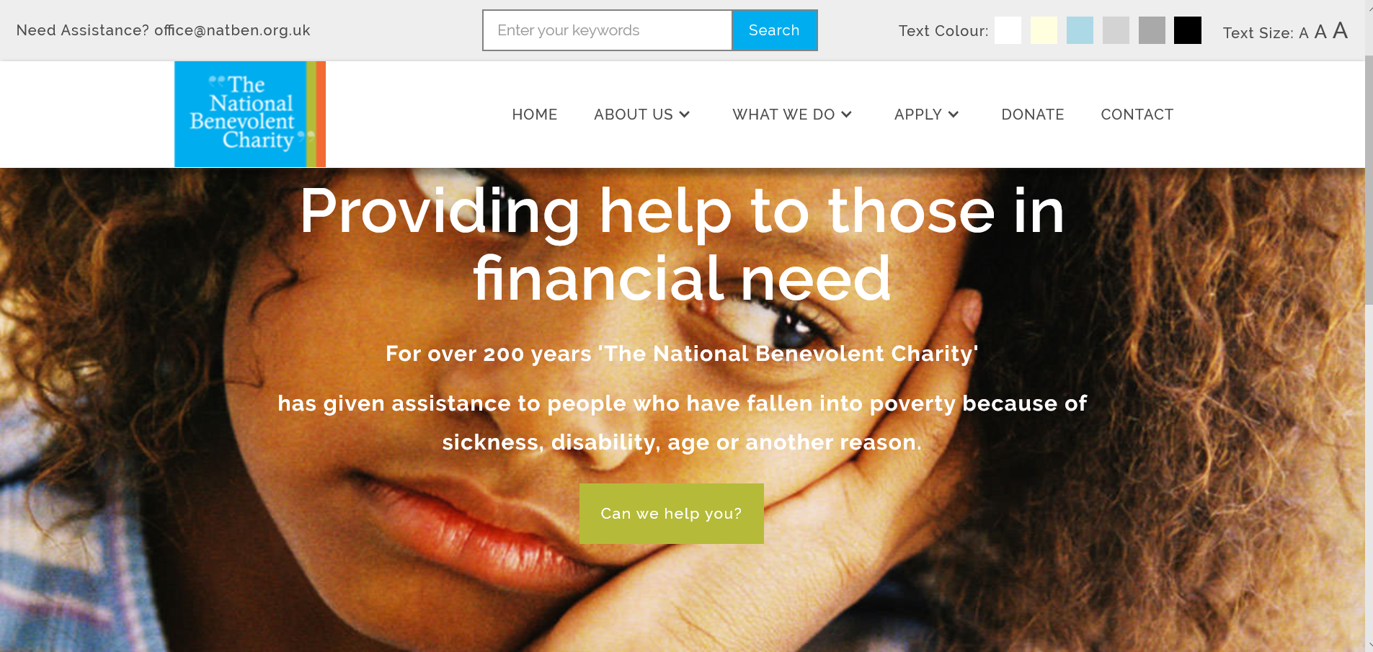

The National Benevolent Charity gives financial help and support to people who, through no fault of their own, are living in poverty. They can make grants to meet essential needs, purchase and arrange delivery of household items and supply vouchers for goods and services. Occasionally, the charity can make a weekly payment to supplement a meagre income and help the beneficiary through a difficult period.
The application process is straightforward but there are some strict criteria – applicants are asked to check they meet the criteria before applying. A supporting reference will also be required.
https://natben.org.uk/apply-for-assistance
----------------------------
Banks to Offer Customers with Coronavirus Help with Overdrafts and Mortgages
Banks, building societies and credit card providers will offer mortgage holidays and other assistance to customers hit with coronavirus (COVID-19), the trade body for the industry announced.
Customers may be offered repayment holidays for mortgages and loans and extended overdraft if their finances suffer while they’re ill or self-isolating, UK Finance said.
Stephen Jones, chief executive of the trade association, said: “All providers are ready and able to offer support to their customers who are impacted directly or indirectly by COVID-19, which could include offering or increasing an overdraft or allowing repayment relief for loan or mortgage repayments: asking for help early is key.”
He urged impacted customers to contact their provider as soon as possible to discuss the assistance available. https://www.moneyexpert.com/banks/banks-offer-customers-coronavirus-help-overdrafts-mortgages
--------------------------
Family Action Welfare
Family Action’s Welfare Grants programme aims to help prevent an immediate crisis from spiralling and threatening the stability of families and individuals.
Welfare grants are an integral part of their whole family approach to finding solutions for those who need it the most. Coupled with emotional and practical support, grants help Family Action to create a safety net for the most vulnerable and disadvantaged members of our society.
https://www.family-action.org.uk/what-we-do/grants/welfare-grants/

