Examples of what you can contribute to the EYFS profile…

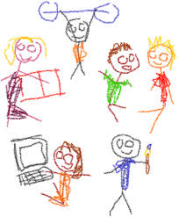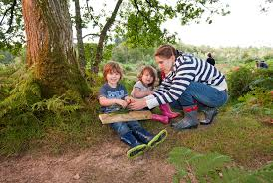
Pictures of family / home life. Photos of family life / trips.

Post it notes giving us information about an achievement / something your child can do or knows about…

