Governor profile
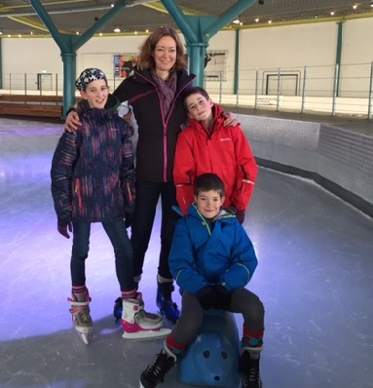 Carla Bradshaw with Kate, George & Harry.
Hello
I became a governor when my oldest child Kate came to school in September 2008 and have been Chair of Governors since 2009. Governors are representing different categories of our community and I am the ‘Local Authority’ governor for our governing body, which means I present the Local Authority view in our discussions. A governor’s role is a strategic one; the government expects us to help set the Federation’s vision and values, ensure appropriate financial management and high standards of education. This means having an understanding of the schools’ strengths and weaknesses, support the improvement plan, attend meetings and training, and act in the best interests of all pupils. Growing up, my father was a governor at my primary school and was involved in a variety of other community roles, so it seemed natural for me to become involved and help support my children’s education too. My interests as a governor are around Finance and the Early Years (Reception Classes and Little Stars). My professional back ground in finance gives me skills and insight which I try to bring to the governors role. I have a general interest in children’s early years in life and was extensively involved with the NCT (National Childbirth Trust) before my children came to school, which resulted in the link to Early Years. I am also a member of the Little Explorers management committee.

