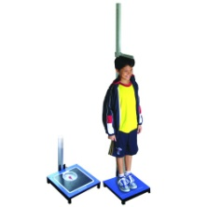
During the Spring term the Reception and Year 6 children are having their height and weight recorded by the School Nurses on behalf of The Local Authority Public Health, as part of the National Child Measurement Programme. Nationally this data is sent anonymously to the Department of Health who use the BMI (Body Mass Index) calculated from the measurements to target relevant services to specific areas of the country.
Locally this data is kept on your child’s health notes and soon you will be sent a letter informing you of which range your child’s BMI falls into. It is important to remember that whilst this BMI data is useful to show national trends, individually it may produce some unexpected results. The BMI ranges try to account for the fact that children are constantly growing but occasionally an anomaly will occur and a child who looks to be in proportion will record a BMI outside the ‘healthy range’.
If you receive a letter that puts your child into a different range to one you were expecting or you have a concern regarding your child’s growth, please contact the School Nursing Team who will be happy to look at individual data and offer any support or advice.

The School Nursing Team is now able to offer a programme to advise and support any family/child who feel they need to make changes for a healthier lifestyle. The programme runs for 12 weeks and would involve regular contact by telephone and meetings.
If you are interested please contact your School Nurse on 821388 to see if this programme could help your family.

